AI - powered Expenses Analyzer

Abstract:
The AI-Powered Expenses Analyzer is a web-based application designed to simplify and enhance personal financial management through automation and intelligent data processing. In today’s digital era, individuals face significant challenges in tracking their daily income and expenses due to busy lifestyles and reliance on manual methods. Traditional approaches such as maintaining handwritten records or using basic applications are often inefficient, time-consuming, and prone to human error. This project addresses these challenges by providing an integrated platform that enables users to manage their financial activities efficiently while leveraging basic artificial intelligence techniques for automation.
The system allows users to record, update, and monitor their income and expenses through a user-friendly interface. One of the key features of this application is its ability to generate detailed financial reports, including daily, monthly, and yearly summaries. These reports help users gain better insights into their spending patterns and make informed financial decisions. Additionally, the system incorporates graphical visualization tools such as bar charts and pie charts, which present financial data in a clear and understandable format.
A unique and significant aspect of this project is the integration of Optical Character Recognition (OCR) technology. This feature enables the system to scan bills or receipts and automatically extract relevant information such as date, amount, and category. By reducing the need for manual data entry, the OCR functionality improves accuracy and saves time, making the system more efficient and user-friendly. Although it is not a fully advanced artificial intelligence system, the use of OCR introduces an element of intelligent automation that enhances the overall functionality of the application.
The application is developed using Java-based web technologies, including Java Servlets and JavaServer Pages (JSP) for backend and frontend development. The system is deployed on an Apache Tomcat server, ensuring scalability and reliability. MySQL is used as the primary database for storing user and transaction data, providing efficient data management and retrieval. The modular design of the system ensures that different components such as authentication, expense management, reporting, and OCR integration function seamlessly together.
Security is also an important aspect of the system, with user authentication mechanisms ensuring that personal financial data remains protected. The application is designed to be accessible through standard web browsers, making it convenient for users without requiring additional software installations.
CHAPTER 1
INTRODUCTION
Introduction
In the modern digital era, effective financial management has become an essential part of everyday life. Individuals are required to monitor their income and expenses carefully in order to maintain financial stability and achieve future goals. However, many people still rely on traditional methods such as maintaining handwritten records or using simple tools like spreadsheets. These methods are often inefficient, time-consuming, and prone to errors, making it difficult for users to track their financial activities accurately. As a result, there is a growing need for an intelligent and automated system that can simplify the process of expense management.
With the rapid advancement of web technologies and data processing techniques, modern applications have the potential to provide efficient solutions for managing personal finances. Expense tracking systems have evolved significantly, offering features such as real-time monitoring, data visualization, and report generation. However, many existing applications still depend heavily on manual data entry, which can lead to inconsistencies and inaccuracies. Users may forget to record transactions or may enter incorrect details, which reduces the reliability of financial analysis.
The AI-Powered Expenses Analyzer is developed to address these challenges by introducing automation and intelligent features into the expense management process. The system is a web-based application that allows users to record, manage, and analyze their income and expenses in a structured and efficient manner. It provides a centralized platform where users can maintain all their financial records and access them anytime through a web browser.
One of the key features of this system is the integration of Optical Character Recognition (OCR) technology. This feature enables the application to scan bills and receipts and automatically extract important details such as amount, date, and category. By reducing manual data entry, the system minimizes human errors and improves data accuracy. This intelligent automation makes the application more user-friendly and efficient compared to traditional expense tracking methods.
In addition to automation, the system also focuses on data analysis and visualization. It generates detailed reports on a daily, monthly, and yearly basis, helping users understand their spending patterns. Graphical representations such as pie charts and bar graphs provide a clear and visual understanding of financial data, enabling users to make informed decisions. This feature is particularly useful for identifying unnecessary expenses and improving budgeting habits.
The application is developed using Java-based technologies such as Java Servlets and JavaServer Pages (JSP), ensuring reliability and scalability. MySQL is used as the database for efficient data storage and retrieval, while Apache Tomcat serves as the deployment platform. The system follows a modular design approach, making it easy to maintain and extend in the future.
Aim of the Project
The primary aim of the AI-Powered Expenses Analyzer project is to design and develop an intelligent, efficient, and user-friendly system that helps individuals manage their personal finances effectively. In today’s fast-paced world, people often find it difficult to keep track of their daily expenses and income, which can lead to poor financial planning and unnecessary spending. This project aims to address these issues by providing a centralized digital platform that simplifies financial tracking and enhances decision-making through automation and data analysis.
One of the key objectives of the project is to eliminate the dependency on manual methods of expense tracking. Traditional approaches such as maintaining notebooks or using basic applications require users to enter every detail manually, which is time-consuming and prone to errors. The proposed system aims to overcome this limitation by introducing automation through Optical Character Recognition (OCR) technology. This feature allows users to scan bills and receipts, enabling the system to automatically extract important information such as date, amount, and category. By reducing manual effort, the system improves accuracy and saves valuable time.
Another important aim of the project is to provide meaningful insights into users’ financial behavior. Simply recording expenses is not sufficient; users need to understand their spending patterns in order to make better financial decisions. The system achieves this by generating detailed reports on a daily, monthly, and yearly basis. These reports are presented using graphical visualizations such as bar charts and pie charts, making it easier for users to analyze their financial data. This helps users identify areas where they are overspending and encourages better budgeting practices.
The project also aims to ensure data security and privacy. Since financial information is sensitive, it is important to protect user data from unauthorized access. The system includes a secure authentication mechanism that allows only registered users to access their personal financial records. This ensures that user data remains confidential and protected.
In addition, the system is designed to be accessible and easy to use. A simple and intuitive user interface is developed to ensure that users of all technical backgrounds can operate the application without difficulty. The web-based nature of the system allows users to access their financial data from anywhere using a standard web browser, without the need for installing additional software.
The project further aims to demonstrate the practical application of web technologies combined with basic artificial intelligence concepts. By integrating OCR functionality into a financial management system, the project showcases how intelligent automation can enhance traditional applications. It also provides a foundation for future enhancements such as machine learning-based expense prediction, mobile application development, and cloud integration.
OBJECTIVES OF THE PROJECT
The AI-Powered Expenses Analyzer project is developed with the objective of providing a smart and efficient solution for managing personal financial activities. One of the primary objectives of this system is to simplify the process of tracking income and expenses. Many individuals find it difficult to maintain accurate financial records due to manual entry methods and lack of proper tools. This project aims to provide a centralized platform where users can easily record, update, and manage their financial transactions in a structured manner.
Another important objective of the project is to reduce the dependency on manual data entry by incorporating automation. The system integrates Optical Character Recognition (OCR) technology, which allows users to scan bills and receipts. The extracted information, such as date, amount, and category, is automatically processed and stored in the system. This reduces the chances of human error and improves the overall efficiency of expense tracking. By minimizing manual input, the system ensures faster and more accurate data entry.
The project also aims to provide detailed financial analysis to help users understand their spending patterns. The system generates reports on a daily, monthly, and yearly basis, allowing users to monitor their financial activities over different time periods. These reports are presented using graphical visualizations such as pie charts and bar graphs. The visual representation of data helps users quickly identify trends, such as high spending categories or irregular expenses, enabling them to make better financial decisions.
Ensuring data accuracy and consistency is another key objective of this project. The system is designed to store financial data in a well-structured database, which helps maintain consistency and avoids data redundancy. Proper validation mechanisms are implemented to ensure that only correct and relevant data is entered into the system. This improves the reliability of the reports and analysis generated by the application.
The project also focuses on providing a secure environment for managing financial data. User authentication is implemented to ensure that only authorized users can access their accounts. This protects sensitive financial information from unauthorized access and ensures privacy. Security measures such as password protection and session management are used to maintain data integrity and confidentiality.
Another objective of the system is to create a user-friendly interface that can be easily used by individuals with different levels of technical knowledge. The application is designed with simplicity in mind, ensuring smooth navigation and easy interaction. Users can perform tasks such as adding expenses, viewing reports, and scanning bills without any complexity. This enhances the overall user experience and encourages regular usage of the system.
The project also aims to utilize modern web technologies for efficient system development. It is built using Java Servlets and JavaServer Pages (JSP) for backend and frontend development, along with MySQL for database management. The use of these technologies ensures that the system is scalable, reliable, and capable of handling multiple users simultaneously.

SCOPE OF THE PROJECT
The AI-Powered Expenses Analyzer project is designed to provide an efficient and intelligent solution for managing personal financial activities. The scope of this project primarily focuses on developing a web-based application that enables users to record, track, and analyze their income and expenses in a systematic manner. The system is intended for individual users who want to maintain a clear understanding of their financial status and improve their budgeting habits.
The application allows users to perform essential financial operations such as adding, updating, and deleting income and expense records. It supports categorization of expenses, which helps users organize their spending into different groups such as food, travel, shopping, and utilities. This categorization makes it easier to analyze where money is being spent and identify areas where expenses can be reduced. The system also maintains historical data, allowing users to review their past financial transactions whenever required.
Another important aspect within the scope of the project is the generation of reports. The system provides detailed reports on a daily, monthly, and yearly basis. These reports help users understand their financial patterns over time and monitor their savings and expenditures. In addition to textual reports, the system includes graphical visualization features such as pie charts and bar graphs. These visual tools enhance data interpretation by presenting financial information in a clear and interactive format.
A key feature included in the scope of this project is the integration of Optical Character Recognition (OCR) technology. This functionality enables the system to scan bills and receipts and automatically extract relevant information such as date, amount, and vendor details. This reduces the need for manual data entry and improves accuracy. The OCR feature is designed to work with standard bill images and provides a basic level of intelligent automation within the system.
The system also includes user authentication and session management, ensuring that each user’s financial data is stored securely and accessed only by authorized individuals. This makes the application suitable for handling sensitive personal financial information. The web-based nature of the system allows users to access it from any device with a browser, making it convenient and easily accessible.
From a technical perspective, the project is developed using Java Servlets and JavaServer Pages (JSP) for backend and frontend operations, along with MySQL for database management. The system is deployed on an Apache Tomcat server, ensuring stable performance and scalability for multiple users. The modular structure of the application allows for easy maintenance and future expansion.
The scope of the project is limited to personal expense management and does not include integration with banking systems or real-time financial transactions. It does not support multi-user financial sharing or enterprise-level accounting features. However, the system provides a strong foundation for further development, where advanced features such as mobile application support, cloud integration, and AI-based expense prediction can be added.

METHODOLOGY
The development of the AI-Powered Expenses Analyzer follows a systematic and structured methodology to ensure that the final system is efficient, reliable, and user-friendly. The project is developed using a step-by-step approach that includes requirement analysis, system design, implementation, testing, and deployment. This methodology helps in organizing the development process and ensures that all user requirements are properly addressed.
The first phase of the methodology is requirement analysis. In this stage, the needs of the users are identified and analyzed. The main requirement is to develop a system that can efficiently track income and expenses while reducing manual effort. Additional requirements include report generation, graphical visualization, and automation through OCR technology. Functional and non-functional requirements are clearly defined to guide the development process.
The next phase is system design. In this stage, the overall architecture of the system is planned. Various design diagrams such as data flow diagrams, use case diagrams, and database schema are created to provide a clear understanding of how the system will function. The design phase also involves defining the structure of modules such as user authentication, expense management, report generation, and OCR processing. A well-planned design ensures that the system is scalable and easy to maintain.
After the design phase, the implementation phase begins. The system is developed using Java Servlets and JavaServer Pages (JSP) for backend and frontend functionality. The database is managed using MySQL, which stores user information and financial records. The OCR functionality is integrated using suitable libraries to enable automatic extraction of data from bill images. During implementation, each module is developed separately and later integrated to form a complete system. Proper coding standards are followed to ensure readability and maintainability.
The next stage is testing, which plays a crucial role in ensuring the quality of the system. Different types of testing such as unit testing, integration testing, and system testing are performed. Unit testing is used to verify the functionality of individual modules, while integration testing ensures that all modules work together correctly. System testing is conducted to evaluate the overall performance of the application. Errors and bugs identified during testing are fixed to improve system reliability.
Once testing is completed, the system is deployed on an Apache Tomcat server. Deployment involves configuring the server environment and making the application accessible through a web browser. After deployment, the system is monitored to ensure that it functions smoothly under different conditions.
The methodology also includes user interaction and feedback. Users are encouraged to test the system and provide feedback, which can be used for further improvements. The modular design of the system allows easy updates and enhancements without affecting existing functionality.
This structured methodology ensures that the AI-Powered Expenses Analyzer is developed in an organized manner, meeting all functional requirements while maintaining quality, efficiency, and scalability throughout the development process
Literature Survey
The development of the AI-Powered Expenses Analyzer is supported by various studies and existing systems related to personal finance management, expense tracking applications, and Optical Character Recognition (OCR) technology. A literature survey helps in understanding the current solutions available, their limitations, and how the proposed system can improve upon them.
Several expense management applications such as Wallet, Money Manager, and Expense Tracker have been widely used for recording daily financial transactions. These systems provide basic functionalities such as adding income and expenses, categorizing transactions, and generating reports. While these applications are useful, they largely depend on manual data entry, which can be time-consuming and prone to errors. Users often forget to record transactions or enter incorrect data, leading to inaccurate financial analysis. This highlights the need for a system that reduces manual effort and improves data accuracy.
Research studies on personal finance management systems emphasize the importance of data visualization and reporting. Many existing systems include graphical representations such as pie charts and bar graphs to help users understand their spending patterns. Visualization plays a key role in financial decision-making, as it allows users to easily identify trends and patterns in their expenses. However, some systems lack advanced analytical features and fail to provide meaningful insights beyond basic summaries.
Optical Character Recognition (OCR) is another important area explored in the literature. OCR technology is widely used for converting printed or handwritten text into machine-readable format. It has applications in various fields such as document digitization, banking, and data entry automation. Studies have shown that OCR can significantly reduce manual effort and improve efficiency in data processing tasks. In the context of expense management, OCR can be used to extract information from bills and receipts, making the process faster and more accurate. However, many existing expense tracking systems do not fully utilize this technology.
Recent research also explores the integration of artificial intelligence in financial applications. AI techniques are used for tasks such as expense prediction, fraud detection, and automated categorization of transactions. While advanced AI-based systems offer powerful features, they are often complex and require large datasets and computational resources. For individual users, a simpler approach that combines basic automation with practical functionality is more suitable.
The AI-Powered Expenses Analyzer builds upon these existing studies by combining expense tracking, data visualization, and OCR-based automation into a single system. Unlike traditional applications, it reduces manual data entry by allowing users to scan bills and automatically extract relevant information. The system also provides detailed reports and graphical analysis, helping users better understand their financial behavior.

CHAPTER 2
SYSTEM ANALYSIS

Existing System
In the current scenario, most individuals rely on traditional methods and basic digital tools to manage their personal finances. These existing systems include handwritten records, spreadsheet applications like Microsoft Excel, and simple expense tracking mobile or web applications. While these methods provide a basic way to record income and expenses, they are often inefficient and lack advanced features required for effective financial management.
Manual methods such as maintaining notebooks are still commonly used by many individuals. In this approach, users write down their daily expenses and income details. Although this method is simple and does not require technical knowledge, it has several limitations. It is time-consuming, difficult to maintain consistently, and highly prone to human error. Users may forget to record transactions or make mistakes while entering data, which leads to inaccurate financial records. Additionally, retrieving and analyzing data from handwritten records is very difficult and does not provide meaningful insights.
Spreadsheet-based systems, such as those created using Microsoft Excel, offer a slightly improved solution. Users can organize their financial data in a structured format and perform basic calculations. However, these systems still require manual data entry and a certain level of technical knowledge to use formulas and create reports. Many users find it difficult to maintain spreadsheets regularly, and errors in formulas or data entry can lead to incorrect results. Moreover, spreadsheets do not provide automation or intelligent features, limiting their effectiveness.
Existing expense tracking applications provide additional functionalities such as categorization of expenses, report generation, and graphical visualization. These applications allow users to record transactions and view summaries in the form of charts and graphs. While they improve user experience compared to manual methods, they still depend heavily on manual input. Users must enter every transaction detail manually, which can be tedious and time-consuming. In many cases, users fail to maintain consistency, resulting in incomplete or inaccurate data.
Another major limitation of existing systems is the lack of automation. Most applications do not include features that can automatically capture or process expense data. There is no integration of technologies such as Optical Character Recognition (OCR) to extract information from bills or receipts. As a result, users are required to manually enter details even when they have physical proof of transactions, which reduces efficiency.
Additionally, many existing systems do not provide advanced analytical capabilities. While some applications offer basic reports, they may not provide deep insights into spending behavior. Users may find it difficult to identify patterns or trends in their expenses, which limits their ability to make informed financial decisions. Security is also a concern in some cases, as not all systems implement strong authentication and data protection mechanisms.
DISADVANTAGES OF EXISTING SYSTEM
- Requires manual data entry for all income and expenses
- Time-consuming process for recording daily transactions
- High chances of human errors and incorrect data entry
- Users may forget to record transactions, leading to incomplete data
- Difficult to maintain consistency in tracking expenses
- Lack of automation in capturing financial data
- No integration of OCR or intelligent technologies
- Limited data analysis capabilities
- Provides only basic reports without deep insights
- Difficult to identify spending patterns and trends
- Poor data visualization in some systems
- Requires technical knowledge (especially in spreadsheets like Excel)
- Risk of data loss in manual or unprotected systems
- Lack of proper security and authentication mechanisms
- Not user-friendly for non-technical users
- No real-time financial monitoring
- Inefficient in handling large amounts of data
- Does not support smart decision-making features
- No automatic categorization of expenses
- Difficulty in tracking recurring expenses (rent, bills, subscriptions)
- Lack of real-time alerts or notifications for overspending
- No support for bill/receipt scanning
- Duplicate data entry may occur due to lack of validation
- Limited or no customization options for users
- Poor user interface design in some applications
- Not accessible across multiple devices or platforms
- No backup or recovery mechanism in many systems
- Difficulty in sharing or exporting reports
- No support for multi-user access or family budgeting
- Limited integration with modern technologies (AI/ML)
- No predictive analysis or future expense estimation
- Inability to set and track financial goals or budgets
- Poor handling of unstructured data (like bills, receipts)
- Lack of data synchronization between devices
- Limited support for different currencies or localization
- No proper audit trail or transaction history tracking
- Inefficient search and filtering options
- Does not provide personalized insights or recommendations

Proposed System
The proposed system, AI-Powered Expenses Analyzer, is designed to overcome the limitations of existing expense management methods by introducing automation, accuracy, and intelligent data processing. The system provides a web-based platform where users can efficiently manage their income and expenses through a simple and user-friendly interface. It aims to simplify financial tracking while enhancing the overall user experience with advanced features and meaningful insights.
One of the main features of the proposed system is the ability to record and manage financial transactions in a structured manner. Users can easily add, update, and delete income and expense details. The system supports categorization of expenses into various groups such as food, travel, utilities, and shopping, which helps in better organization and analysis of financial data. All records are securely stored in a centralized database, allowing users to access their information anytime.
A key innovation in the proposed system is the integration of Optical Character Recognition (OCR) technology. This feature enables users to scan bills or receipts using the application, and the system automatically extracts important details such as date, amount, and vendor information. This reduces the need for manual data entry, minimizes errors, and improves efficiency. The OCR functionality introduces a level of intelligent automation, making the system more advanced compared to traditional expense tracking applications.
The system also includes a powerful reporting and analysis module. It generates detailed financial reports on a daily, monthly, and yearly basis, helping users monitor their spending habits over time. In addition to textual reports, the system provides graphical visualizations such as pie charts and bar graphs. These visual representations make it easier for users to understand their financial data and identify trends or patterns. Users can quickly analyze which categories consume the most budget and take necessary actions to control their expenses.
Security is an important aspect of the proposed system. The application includes user authentication features such as login and registration, ensuring that only authorized users can access their financial data. Proper session management techniques are implemented to maintain data privacy and prevent unauthorized access.
From a technical perspective, the system is developed using Java Servlets and JavaServer Pages (JSP), which provide a robust and scalable framework for web application development. MySQL is used as the database for efficient data storage and retrieval. The application is deployed on an Apache Tomcat server, ensuring reliable performance and accessibility through standard web browsers.
The proposed system is designed with a modular architecture, which makes it easy to maintain and extend. Each module, such as authentication, expense management, reporting, and OCR processing, functions independently while being integrated into the overall system. This structure allows future enhancements to be added without affecting existing functionalities.
The system also focuses on usability by providing a clean and intuitive interface. Users can navigate through different features easily, making the application suitable for individuals with varying levels of technical knowledge. The web-based nature of the system ensures accessibility from different devices without requiring additional installations.

Workflow of the Proposed System
The workflow of the AI-Powered Expenses Analyzer describes the step-by-step process through which the system operates, starting from user interaction to data processing and output generation. The system is designed to provide a smooth and efficient flow of operations, ensuring that users can easily manage their financial activities with minimal effort.
The workflow begins with user authentication. A new user must first register by providing basic details such as username, email, and password. Once registered, the user can log in securely using valid credentials. This authentication process ensures that only authorized users can access the system and their financial data remains protected.
After successful login, the user is directed to the dashboard, which serves as the central interface of the application. From the dashboard, users can navigate to different modules such as income management, expense management, reports, and bill scanning. The dashboard may also display a summary of recent transactions and overall financial status.
In the income and expense management modules, users can manually add their financial records by entering details such as amount, date, category, and description. The system validates the input data before storing it in the database to ensure accuracy and consistency. Users also have the option to edit or delete existing records as needed.
A key part of the workflow is the bill scanning process using OCR technology. When a user uploads an image of a bill or receipt, the system processes the image using OCR techniques to extract relevant information such as total amount, date, and vendor name. The extracted data is then displayed to the user for verification. Once confirmed, the data is automatically saved as an expense entry in the system. This reduces manual effort and speeds up the data entry process.
All financial data entered by the user, whether manually or through OCR, is stored in a structured database. The system organizes this data based on categories and time periods, making it easy to retrieve and analyze when needed.
The reporting and analysis module plays a crucial role in the workflow. The system processes stored data to generate reports on a daily, monthly, and yearly basis. These reports provide detailed insights into income, expenses, and overall financial balance. In addition to textual reports, the system generates graphical visualizations such as pie charts and bar graphs. These visual representations help users understand their spending patterns and identify trends more effectively.
Users can also filter and search their financial data based on different criteria such as date range or category. This enhances the usability of the system and allows users to focus on specific aspects of their financial activities.
Finally, the user can log out of the system securely after completing their tasks. The system ensures that the session is properly terminated to maintain security.
The entire workflow is designed to be simple, efficient, and user-friendly, integrating manual input, automated data extraction, and analytical processing into a single seamless process.
Advantages of the Proposed System
- Provides automated expense tracking with reduced manual effort
- Integrates OCR technology for bill and receipt scanning
- Minimizes human errors in data entry
- Saves time and effort through automation
- Offers real-time financial tracking
- Generates daily, monthly, and yearly reports
- Includes graphical visualization (pie charts, bar graphs)
- Helps identify spending patterns and trends
- Supports easy categorization of expenses
- Provides a user-friendly interface for smooth navigation
- Ensures data accuracy and consistency
- Secure system with user authentication and session management
- Enables quick data retrieval and filtering
- Accessible from any device via web browser
- Reduces dependency on manual record-keeping
- Supports editing and deletion of records easily
- Improves financial planning and budgeting
- Scalable system that can handle multiple users
- Modular design allows easy maintenance and future upgrades
- Enhances overall user experience with intelligent features
- Supports automatic data extraction from bills using OCR
- Reduces duplicate entries through validation mechanisms
- Provides centralized storage of all financial data
- Improves decision-making with clear financial insights
- Allows custom categorization of expenses
- Enables quick summary view through dashboard
- Provides interactive charts for better understanding
- Ensures high data reliability with structured database
- Supports easy backup and recovery of data
- Reduces paper usage by digitizing receipts and bills
- Improves record maintenance over long periods
- Enables faster report generation
- Supports search and filter functionality for easy navigation
- Provides better organization of financial records
- Reduces financial mismanagement
- Helps in tracking unnecessary expenses
- Encourages smart spending habits
- Compatible with modern web technologies
- Allows easy integration with future AI features
- Provides a foundation for mobile app development

System Architecture (Text Explanation)

The system architecture of the AI-Powered Expenses Analyzer is designed using a multi-tier (three-layer) architecture to ensure scalability, maintainability, and efficient performance. The architecture is divided into three main layers: the presentation layer, the application (business logic) layer, and the data layer. Each layer has a specific role and works together to provide a seamless user experience.
The first layer is the presentation layer, also known as the user interface layer. This layer is responsible for interacting with the user and displaying information. It is developed using JavaServer Pages (JSP), HTML, CSS, and basic JavaScript. Users access the system through a web browser, where they can perform actions such as logging in, adding expenses, viewing reports, and scanning bills. The interface is designed to be simple and user-friendly, allowing users to navigate through different modules easily. All user inputs, such as financial data or uploaded bill images, are collected through this layer and passed to the backend for processing.
The second layer is the application layer, which contains the core logic of the system. This layer is implemented using Java Servlets. It processes user requests received from the presentation layer and performs the necessary operations. For example, when a user adds an expense, the servlet validates the input data, processes it, and sends it to the database for storage. Similarly, when a user requests a report, the application layer retrieves the required data, processes it, and prepares it for display.
A key component of the application layer is the OCR module. When a user uploads a bill or receipt, the system uses OCR technology to extract relevant information such as amount, date, and vendor details. This extracted data is then processed and converted into a structured format that can be stored in the database. The application layer also handles report generation and graphical analysis by organizing data into meaningful insights.
The third layer is the data layer, which is responsible for storing and managing all the information used by the system. MySQL is used as the primary database to store user details, income records, expense records, and other related data. The database is designed with proper tables and relationships to ensure data consistency and avoid redundancy. All interactions with the database are handled through structured queries, ensuring efficient data retrieval and storage.
The system is deployed on an Apache Tomcat server, which acts as the bridge between the presentation and application layers. The server handles incoming requests, processes them through the appropriate servlets, and sends responses back to the user interface.
The overall architecture follows a modular approach, where each component functions independently but is integrated into the system. This makes the system easy to maintain and extend. New features can be added without affecting existing modules.
This layered architecture ensures a clear separation of concerns, improves system performance, and provides a secure and scalable environment for managing personal financial data efficiently.

CHAPTER 3
SYSTEM DESIGN

System Design Overview
The system design of the AI-Powered Expenses Analyzer focuses on creating a structured and efficient framework that supports smooth interaction between users, application logic, and data storage. The design follows a modular and layered approach, ensuring that each component of the system performs a specific function while maintaining overall integration.
The system is divided into key modules such as user authentication, income management, expense management, OCR-based bill scanning, and report generation. Each module is designed to operate independently, allowing easy maintenance and future enhancements. The user interacts with the system through a web-based interface developed using JSP, HTML, and CSS, which provides a simple and intuitive experience.
The backend logic is handled using Java Servlets, which process user requests, perform validations, and manage communication with the database. The database is structured using MySQL, where all financial records and user details are stored securely.
The design also incorporates data flow and interaction diagrams to clearly represent how information moves within the system. Overall, the system design ensures reliability, scalability, and efficient performance while supporting both manual and automated expense tracking features.
ARCHITECTURE DIAGRAM

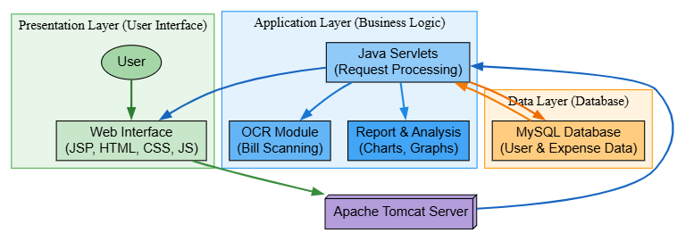

UML CLASS DIAGRAM

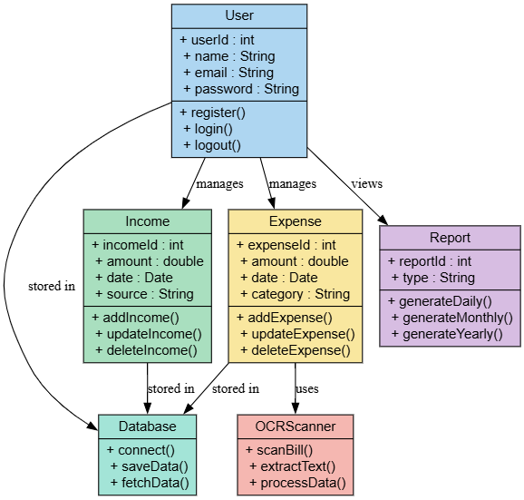

USE CASE DIAGRAM

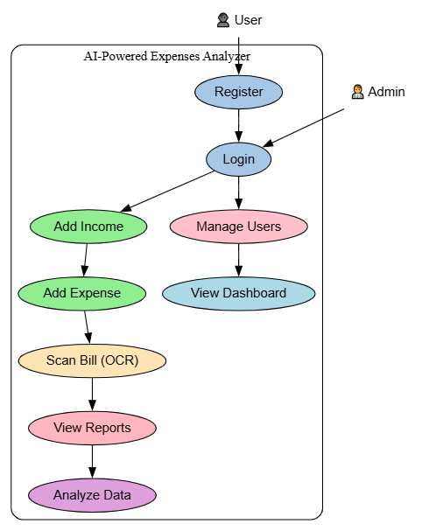

ACTIVITY DIAGRAM

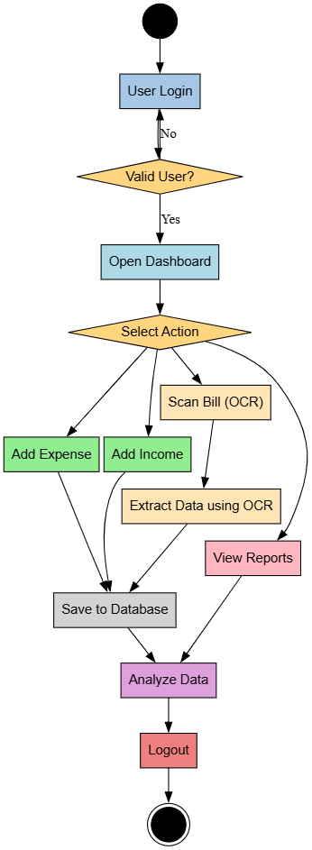

SEQUENCE DIAGRAM

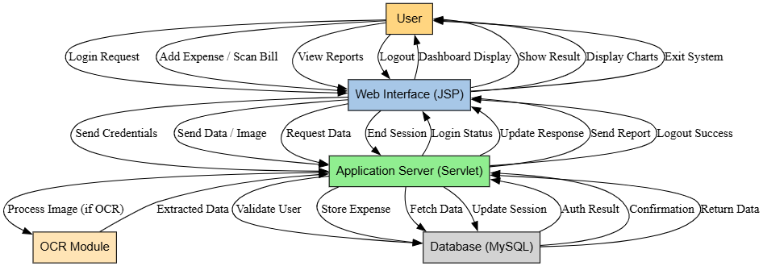

BLOCK DIAGRAM

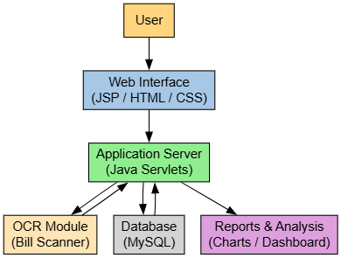

MODULE DESCRIPTION

1. USER AUTHENTICATION MODULE
The User Authentication Module is one of the most important components of the AI-Powered Expenses Analyzer, as it ensures secure access to the system. This module is responsible for handling user registration, login, logout, and session management. It acts as the entry point of the application and protects sensitive financial data from unauthorized access.
The module begins with the registration process, where new users create an account by providing essential details such as username, email, and password. The system validates the input data to ensure that all required fields are filled correctly. It also checks for duplicate email addresses to prevent multiple accounts with the same credentials. Once the data is validated, it is securely stored in the database.
During the login process, users enter their credentials, which are verified against the stored data in the database. If the credentials match, the user is granted access to the system and redirected to the dashboard. If the credentials are incorrect, the system displays an appropriate error message. This ensures that only authorized users can access their financial information.
Session management is another key feature of this module. Once a user logs in successfully, a session is created to maintain the user’s state throughout their interaction with the system. This allows users to navigate between different modules without needing to log in repeatedly. The session is terminated when the user logs out, ensuring security.
To enhance security, the module may include features such as password encryption, input validation, and protection against common vulnerabilities like SQL injection. Proper error handling is implemented to manage invalid login attempts and prevent system crashes.
Overall, the User Authentication Module ensures a secure and reliable environment for users, protecting their personal and financial data while providing seamless access to the system.

- INCOME MANAGEMENT MODULE
The Income Management Module is designed to help users record and manage their income efficiently. It allows users to add, update, view, and delete income records in a structured manner. This module plays a crucial role in maintaining accurate financial data, which is essential for generating reports and analyzing financial performance.
Users can add income details by entering information such as amount, date, source, and description. The system validates the input to ensure that all required fields are correctly filled. Once validated, the data is stored in the database, making it available for future reference and analysis.
The module also allows users to update or delete existing income records. This flexibility ensures that users can correct mistakes or modify their data as needed. All changes are reflected in the database, ensuring consistency and accuracy.
One of the key features of this module is the ability to categorize income sources. This helps users understand where their money is coming from, such as salary, business, or other sources. Categorization improves the clarity of financial reports and supports better decision-making.
The Income Management Module is integrated with the reporting system, allowing users to view their income data in various formats. This includes summaries and graphical representations, which help users analyze their financial status effectively.
Overall, this module provides a simple and efficient way for users to manage their income, ensuring accurate data collection and supporting financial analysis.

3. EXPENSE MANAGEMENT MODULE
The Expense Management Module is a core component of the system, enabling users to track and manage their daily expenses. It allows users to add, update, delete, and view expense records, providing a comprehensive solution for expense tracking.
Users can enter expense details such as amount, date, category, and description. The system validates the input data and stores it in the database. Categories such as food, travel, and utilities help organize expenses and make analysis easier.
The module also supports editing and deleting records, allowing users to maintain accurate data. This flexibility ensures that users can correct errors and keep their financial records up to date.
One of the key features of this module is its integration with the OCR system. Users can upload images of bills, and the system automatically extracts relevant data, reducing manual effort.
The Expense Management Module is closely linked with the reporting system, enabling users to analyze their spending patterns. It provides insights into where money is being spent, helping users make better financial decisions.
Overall, this module ensures efficient expense tracking and plays a vital role in financial management.

4. OCR BILL SCANNING MODULE
The OCR Bill Scanning Module introduces intelligent automation into the system by allowing users to scan bills and receipts. This module uses Optical Character Recognition (OCR) technology to extract text from images and convert it into structured data.
Users can upload images of bills through the application. The OCR engine processes the image and identifies text patterns, extracting relevant details such as amount, date, and vendor name. The extracted data is displayed to the user for verification before being stored in the database.
This module significantly reduces manual data entry, saving time and minimizing errors. It enhances the efficiency of the system and improves user experience.
The OCR module is integrated with the expense management system, automatically creating expense entries based on extracted data. This seamless integration ensures smooth workflow and accurate data processing.
While the accuracy of OCR depends on image quality, the module performs well with clear images. It represents a key innovation in the system, showcasing the use of AI-based technology.

5. REPORTS AND ANALYSIS MODULE
The Reports and Analysis Module provides users with detailed insights into their financial data. It generates reports based on income and expense records, helping users understand their financial behavior.
The system generates reports on a daily, monthly, and yearly basis. These reports include summaries of total income, total expenses, and remaining balance. Users can view their financial data in both tabular and graphical formats.
Graphical representations such as pie charts and bar graphs make it easier to analyze spending patterns. Users can identify which categories consume the most budget and make informed decisions.
The module also supports filtering and searching, allowing users to analyze specific data based on date range or category. This enhances usability and provides flexibility.
Overall, this module transforms raw data into meaningful insights, helping users improve their financial management.

CHAPTER 4
HARDWARE & SOFTWARE REQUIREMENTS
Hardware Requirements:
The AI-Powered Expenses Analyzer is a web-based application that does not require high-end hardware for its operation. However, certain minimum and recommended hardware specifications are necessary to ensure smooth performance, efficient processing, and a better user experience. The system is designed to run on standard computing devices, making it accessible to a wide range of users.
The primary hardware requirement is a computer or laptop with a reliable processor. A minimum of an Intel Core i3 processor or its equivalent is sufficient for basic operations such as running the web application, managing data, and generating reports. For better performance, especially when handling multiple tasks or processing OCR-based bill scanning, a system with an Intel Core i5 or higher processor is recommended. A faster processor helps in reducing processing time and ensures smooth execution of application functions.
Memory (RAM) is another important hardware component. The system requires a minimum of 4 GB RAM to run efficiently. This is adequate for basic usage, including running the web server, database, and browser simultaneously. However, for improved performance and multitasking, 8 GB RAM or higher is recommended. Higher memory capacity allows the system to handle larger datasets and ensures faster data processing, especially when multiple users are accessing the system.
Storage is also a key requirement. A minimum of 256 GB hard disk space is required to store the application files, database, and user data. Solid State Drives (SSD) are preferred over traditional Hard Disk Drives (HDD) as they provide faster data access and improved system performance. The storage requirement may increase over time as more financial data and scanned bill images are stored in the system.
A stable internet connection is essential for accessing the web-based application. Since the system operates through a web browser, users need a reliable network connection to interact with the application and retrieve data from the server. A broadband or Wi-Fi connection with moderate speed is sufficient for smooth operation.
For the OCR functionality, an additional hardware component such as a camera or scanner is required. Users can use a built-in webcam, external camera, or mobile device to capture images of bills and receipts. The quality of the camera affects the accuracy of text extraction, so a camera with good resolution is recommended. Alternatively, users can upload pre-captured images into the system for processing.
Input and output devices such as a keyboard, mouse, and monitor are necessary for user interaction. A standard display monitor is sufficient, but a higher resolution screen can enhance the viewing experience, especially when analyzing graphical reports and charts.
The system can also be deployed on a server machine for multi-user access. In such cases, the server should have higher specifications, including a multi-core processor, at least 8–16 GB RAM, and sufficient storage capacity to handle multiple requests and large amounts of data.
Overall, the hardware requirements for the AI-Powered Expenses Analyzer are moderate, making it a cost-effective and easily deployable solution for personal financial management.

Software Requirements
The AI-Powered Expenses Analyzer requires a set of software components to ensure proper development, deployment, and execution of the system. These software requirements are essential for building a stable, efficient, and user-friendly web application. The system is designed using widely used and reliable technologies, making it easy to develop, maintain, and deploy.
The primary programming language used in this project is Java. Java provides a robust and platform-independent environment for developing web-based applications. It is used for implementing the backend logic of the system through Java Servlets, which handle user requests, process data, and communicate with the database. Java ensures scalability, security, and performance, making it suitable for this application.
For frontend development, JavaServer Pages (JSP), along with HTML and CSS, are used. JSP helps in creating dynamic web pages by embedding Java code within HTML. HTML is used to structure the content of web pages, while CSS is used for styling and improving the visual appearance of the application. These technologies work together to provide a responsive and user-friendly interface.
The system requires Apache Tomcat server for deployment. Apache Tomcat is a widely used web server that supports Java Servlets and JSP. It acts as a bridge between the client and the server, handling HTTP requests and delivering responses. Tomcat ensures smooth execution of the application and supports multiple users accessing the system simultaneously.
MySQL is used as the database management system for storing and managing data. It stores user information, income records, expense details, and OCR-extracted data. MySQL provides efficient data retrieval, security, and scalability. Structured Query Language (SQL) is used to interact with the database for performing operations such as inserting, updating, deleting, and retrieving data.
For development purposes, an Integrated Development Environment (IDE) such as Eclipse or IntelliJ IDEA is required. These IDEs provide tools for writing, debugging, and testing code efficiently. They support Java development and simplify the process of building and deploying the application.
The system also requires a web browser such as Google Chrome, Microsoft Edge, or Mozilla Firefox for accessing the application. The browser acts as the interface through which users interact with the system. A modern browser ensures compatibility and smooth rendering of web pages.
For implementing the OCR functionality, software tools such as Tesseract OCR can be used. Tesseract is an open-source OCR engine that helps in extracting text from images. It plays a key role in automating the data entry process by converting bill images into machine-readable text.
Additionally, the system requires an operating system such as Windows, Linux, or macOS to run the development tools and server environment. The application is platform-independent and can run on any system that supports Java and the required software components.
Proper software configuration and compatibility between these components are essential for the smooth functioning of the system. Together, these software requirements ensure that the AI-Powered Expenses Analyzer operates efficiently, securely, and reliably while providing a seamless user experience.

Frontend Technologies
The frontend of the AI-Powered Expenses Analyzer is responsible for providing an interactive and user-friendly interface through which users can access the system’s features. It plays a crucial role in enhancing user experience by ensuring smooth navigation, clear data presentation, and responsive design. The frontend is developed using a combination of standard web technologies such as HTML, CSS, JavaServer Pages (JSP), and basic JavaScript.
HTML (HyperText Markup Language) is used as the foundation for designing the structure of web pages. It defines the layout and organization of elements such as forms, tables, buttons, and text fields. In this project, HTML is used to create essential pages such as login, registration, dashboard, expense entry forms, and report views. It ensures that all components are properly structured and displayed in the browser.
CSS (Cascading Style Sheets) is used to enhance the visual appearance of the application. It is responsible for styling elements such as colors, fonts, spacing, and layout. CSS improves the overall look and feel of the system, making it more attractive and user-friendly. It also helps in creating a consistent design across all pages. Responsive design techniques can be applied using CSS to ensure that the application works well on different screen sizes and devices.
JavaServer Pages (JSP) is a key frontend technology used in this project. JSP allows the integration of Java code within HTML, enabling the creation of dynamic web pages. It is used to display data retrieved from the backend, such as user details, expense records, and reports. JSP helps in generating dynamic content based on user interactions and database queries, making the application more interactive and efficient.
JavaScript is used to add interactivity and improve the functionality of the frontend. It enables features such as form validation, dynamic content updates, and user input handling without requiring page reloads. For example, JavaScript can be used to validate input fields in expense forms, ensuring that users enter correct data before submission. It enhances the responsiveness of the application and improves user experience.
In addition to these core technologies, frontend components such as charts and graphs are used for data visualization. Libraries or built-in tools can be used to display financial data in the form of pie charts and bar graphs. These visual elements help users understand their spending patterns more effectively.
The frontend is designed with simplicity and usability in mind. Navigation menus, buttons, and forms are organized in a way that allows users to easily access different features of the system. The dashboard provides a summary of financial data, enabling users to quickly view important information.
Overall, the frontend technologies used in the AI-Powered Expenses Analyzer ensure that the application is visually appealing, easy to use, and responsive. They provide a strong interface for interaction between the user and the system, making financial management simple and efficient.

Backend Technologies
The backend of the AI-Powered Expenses Analyzer is responsible for handling the core functionality of the system, including data processing, business logic, database interaction, and integration of intelligent features such as OCR. It acts as the bridge between the frontend interface and the database, ensuring that user requests are processed efficiently and securely. The backend is developed using robust and scalable technologies that support web-based application development.
The primary backend programming language used in this project is Java. Java is widely known for its platform independence, security, and performance. It provides a strong foundation for building enterprise-level web applications. In this system, Java is used to implement the business logic, process user requests, and manage communication between different components of the application.
Java Servlets play a key role in the backend architecture. Servlets are server-side programs that handle HTTP requests and responses. When a user performs an action on the frontend, such as adding an expense or logging in, the request is sent to a servlet. The servlet processes the request, performs necessary operations such as validation and data processing, and then sends a response back to the frontend. Servlets ensure efficient handling of multiple user requests and maintain smooth system performance.
The system uses MySQL as the database management system for storing and retrieving data. MySQL is a reliable and widely used relational database that supports structured data storage. It stores all essential information, including user details, income records, expense data, and OCR-extracted information. Structured Query Language (SQL) is used to perform operations such as inserting, updating, deleting, and retrieving data from the database. Proper database design ensures data consistency, integrity, and efficient query execution.
Another important backend component is the OCR (Optical Character Recognition) module. This module is responsible for extracting text from bill or receipt images uploaded by the user. Tools such as Tesseract OCR can be integrated into the system to perform this function. The OCR module processes the image, identifies text patterns, and converts them into machine-readable data. This data is then passed to the application logic, where it is structured and stored in the database. This feature reduces manual data entry and enhances the overall efficiency of the system.
Apache Tomcat server is used as the application server for deploying and running the backend components. Tomcat provides a runtime environment for Java Servlets and JSP, handling client requests and delivering responses. It ensures that the application runs smoothly and supports multiple users simultaneously.
The backend also includes validation and security mechanisms. Input validation ensures that only correct and meaningful data is processed by the system. Authentication and session management are implemented to protect user data and prevent unauthorized access. These measures enhance the reliability and security of the application.
Overall, the backend technologies used in the AI-Powered Expenses Analyzer provide a strong and efficient framework for processing data, managing system operations, and delivering reliable performance. They ensure seamless integration between the frontend and database while supporting intelligent features and secure data handling.

Database Technologies
The AI-Powered Expenses Analyzer relies on a robust and efficient database system to store, manage, and retrieve financial data. The database plays a critical role in ensuring data consistency, security, and performance of the application. In this project, MySQL is used as the primary database management system due to its reliability, scalability, and ease of integration with Java-based web applications.
MySQL is an open-source relational database management system (RDBMS) that stores data in structured tables consisting of rows and columns. It supports Structured Query Language (SQL), which is used to perform various database operations such as inserting, updating, deleting, and retrieving data. The use of MySQL ensures that all financial records, including user details, income entries, expense transactions, and OCR-extracted data, are stored in an organized and efficient manner.
The database design follows a relational model, where multiple tables are created to represent different entities of the system. Common tables include user, income, expense, category, and transaction tables. Each table contains specific attributes, and relationships are established between them using primary keys and foreign keys. This structured design helps maintain data integrity and avoids redundancy. For example, each expense record is linked to a specific user, ensuring that data is properly organized and easily retrievable.
Data normalization techniques are applied to eliminate redundancy and improve database efficiency. By organizing data into multiple related tables, the system ensures that updates and modifications can be performed without affecting other parts of the database. This improves the consistency and reliability of the stored information.
The database also supports indexing, which enhances the speed of data retrieval. Indexes are created on important fields such as user ID, date, and category, allowing faster query execution. This is particularly useful when generating reports or searching for specific transactions within a large dataset.
Another important aspect of the database is its ability to handle concurrent access. Multiple users can access the system simultaneously, and MySQL ensures that data transactions are processed correctly without conflicts. It supports transaction management features such as commit and rollback, which help maintain data consistency even in case of errors or system failures.
Security is a key consideration in database management. MySQL provides mechanisms such as user authentication, access control, and encryption to protect sensitive financial data. Only authorized users are allowed to access or modify data, ensuring privacy and confidentiality.
The database also supports backup and recovery mechanisms. Regular backups can be taken to prevent data loss in case of system failures or unexpected issues. This ensures that user data remains safe and can be restored when needed.
Integration between the database and the backend is achieved using JDBC (Java Database Connectivity). JDBC allows Java applications to connect to the MySQL database and execute SQL queries. This enables seamless communication between the application logic and the data layer.
Overall, the use of MySQL as the database technology ensures efficient data management, high performance, and strong security. It provides a reliable foundation for storing and analyzing financial data in the AI-Powered Expenses Analyzer system.

Libraries and Dependencies
The AI-Powered Expenses Analyzer utilizes various libraries and dependencies to enhance functionality, simplify development, and ensure efficient performance of the system. These libraries provide pre-built functionalities that reduce development time and help in implementing complex features such as database connectivity, OCR processing, and web application handling.
One of the core dependencies used in the project is the Java Servlet API. This library is essential for building the backend of the application, as it enables handling of HTTP requests and responses. Servlets act as the controller in the application, processing user inputs and interacting with the database. The Servlet API ensures smooth communication between the client and server.
Another important dependency is JavaServer Pages (JSP) libraries. JSP is used to create dynamic web pages by embedding Java code within HTML. It allows the application to display data retrieved from the database in a structured and interactive manner. JSP simplifies the development of the frontend while maintaining a strong connection with backend logic.
For database connectivity, the project uses JDBC (Java Database Connectivity). JDBC is a standard Java API that allows the application to connect to the MySQL database. It provides methods for executing SQL queries, retrieving results, and managing database transactions. The MySQL Connector/J driver is used as a dependency to establish the connection between Java and the MySQL database.
The OCR functionality in the system is implemented using libraries such as Tesseract OCR. Tesseract is an open-source optical character recognition engine that enables the extraction of text from images. It plays a crucial role in automating the process of reading data from bills and receipts. The integration of Tesseract with Java is achieved through wrapper libraries that allow seamless communication between the application and the OCR engine.
For handling file uploads, the system may use libraries such as Apache Commons FileUpload. This library simplifies the process of uploading images or documents to the server. It supports handling multipart/form-data requests and ensures that uploaded files are processed securely and efficiently.
To improve logging and debugging, libraries such as Log4j or Java Logging API can be used. These libraries help in tracking system activities, identifying errors, and maintaining logs for future analysis. Proper logging is important for maintaining system reliability and troubleshooting issues.
For frontend enhancements, basic JavaScript libraries may be used to improve interactivity and validation. These libraries help in validating user inputs, managing dynamic content, and enhancing the overall user experience.
The project may also include dependency management tools such as Maven. Maven helps in managing project dependencies, automating build processes, and maintaining a structured project environment. It ensures that all required libraries are properly included and updated.
All these libraries and dependencies work together to provide a complete and efficient system. They reduce the complexity of development by offering ready-to-use functionalities and ensure that the application performs reliably. Proper integration and management of these dependencies are essential for the smooth functioning of the AI-Powered Expenses Analyzer.

Development Tools
The development of the AI-Powered Expenses Analyzer requires a set of reliable and efficient tools to support coding, testing, deployment, and overall project management. These development tools help streamline the development process, improve productivity, and ensure the quality of the final application. The tools used in this project are widely adopted in the software industry and are well-suited for Java-based web application development.
One of the primary development tools used is an Integrated Development Environment (IDE) such as Eclipse IDE or IntelliJ IDEA. These IDEs provide a comprehensive environment for writing, editing, and debugging code. They support Java development and offer features such as syntax highlighting, code auto-completion, error detection, and project management. Eclipse, in particular, is commonly used for developing Java web applications and provides built-in support for Java Servlets, JSP, and server configuration. IntelliJ IDEA offers advanced features and a more user-friendly interface, making development faster and more efficient.
Apache Tomcat is another essential tool used for deploying and running the application. It is a web server and servlet container that supports Java Servlets and JSP. Tomcat allows developers to test the application locally before deploying it to a production environment. It handles client requests, processes them through the backend, and sends responses back to the user. Tomcat ensures that the application runs smoothly and supports multiple users simultaneously.
For database management, tools such as MySQL Workbench or phpMyAdmin are used. These tools provide a graphical interface for managing the MySQL database. Developers can create tables, define relationships, execute SQL queries, and monitor database performance. MySQL Workbench is particularly useful for designing database schemas and visualizing relationships between tables.
Version control systems such as Git are used to manage source code effectively. Git allows developers to track changes, collaborate with team members, and maintain different versions of the project. Platforms like GitHub or GitLab can be used to host the project repository, making it easier to share and manage code.
For frontend design and testing, web browsers such as Google Chrome or Microsoft Edge are used. These browsers provide developer tools that help in inspecting elements, debugging JavaScript, and testing the responsiveness of web pages. They play a crucial role in ensuring that the user interface functions correctly across different environments.
Build and dependency management tools such as Maven can also be used in the project. Maven helps in managing project dependencies, compiling code, and packaging the application into deployable formats such as WAR files. It simplifies the build process and ensures that all required libraries are included correctly.
For OCR functionality, tools like Tesseract OCR need to be installed and configured. These tools are used during development to test and integrate the bill scanning feature into the application.
Additionally, tools such as Notepad++ or Visual Studio Code may be used for quick editing of files, especially for HTML, CSS, and configuration files. These lightweight editors provide flexibility and ease of use.
Overall, these development tools play a vital role in building the AI-Powered Expenses Analyzer. They support the entire development lifecycle, from coding and testing to deployment and maintenance, ensuring that the application is developed efficiently and performs reliably.
CHAPTER 5
IMPLEMENTATION & RESULTS
Implementation Overview
The implementation of the AI-Powered Expenses Analyzer involves the practical development of the system based on the designed architecture and defined requirements. This phase focuses on converting the system design into a functional web application using appropriate technologies and tools. The implementation is carried out in a modular approach, ensuring that each component of the system is developed, tested, and integrated effectively.
The development process begins with setting up the development environment, which includes installing Java JDK, configuring Apache Tomcat server, and setting up MySQL database. An Integrated Development Environment (IDE) such as Eclipse is used to create and manage the project structure. The project is organized into different packages and folders for better code management, including separate directories for servlets, JSP pages, and configuration files.
The frontend implementation is carried out using JSP, HTML, and CSS. Various web pages are created to support user interactions, including login, registration, dashboard, income entry, expense entry, and report viewing pages. These pages are designed to be user-friendly and responsive, allowing users to easily navigate through different functionalities. Forms are used to collect user inputs, which are then sent to the backend for processing.
The backend implementation is developed using Java Servlets. Each major functionality of the system is handled by specific servlets. For example, authentication servlets handle user login and registration, while other servlets manage income and expense operations. The servlets process user requests, perform validation, and interact with the database using JDBC. Proper exception handling is implemented to ensure system stability and to manage errors effectively.
The database is implemented using MySQL, where multiple tables are created to store user information, income records, expense details, and OCR data. The database schema is designed to maintain relationships between different entities, ensuring data consistency and integrity. SQL queries are used to perform CRUD (Create, Read, Update, Delete) operations on the data.
A key part of the implementation is the integration of the OCR module. The OCR functionality is implemented using tools such as Tesseract OCR, which processes uploaded images of bills or receipts. The extracted text is parsed and relevant details such as amount and date are identified and stored in the database. This feature reduces manual data entry and enhances the efficiency of the system.
The application is deployed on the Apache Tomcat server, which allows users to access the system through a web browser. The server handles client requests and ensures smooth communication between the frontend and backend components.
Testing is performed throughout the implementation phase to ensure that each module functions correctly. Both manual and automated testing techniques are used to identify and fix bugs. Once all modules are integrated and tested, the system is ready for deployment.
The implementation phase ensures that the AI-Powered Expenses Analyzer operates as a fully functional, efficient, and user-friendly application that meets all the specified requirements.

Coding Description
The coding of the AI-Powered Expenses Analyzer is carried out using a structured and modular approach to ensure clarity, maintainability, and efficiency. The project is developed using Java for backend processing, JavaServer Pages (JSP) for frontend rendering, and MySQL for database management. The code is organized into different components such as servlets, JSP pages, utility classes, and database connectivity modules.
The backend logic is primarily implemented using Java Servlets. Each servlet is responsible for handling a specific functionality of the system. For example, the login servlet processes user authentication by receiving credentials from the frontend, validating them against the database, and creating a session for the user upon successful login. Similarly, other servlets handle operations such as adding income, recording expenses, updating data, and generating reports. The servlets follow a standard structure, including methods such as doGet() and doPost() to handle HTTP requests.
Database connectivity is achieved using JDBC (Java Database Connectivity). A separate utility class is created to manage database connections, ensuring that connections are established and closed efficiently. SQL queries are written to perform CRUD operations such as inserting new records, updating existing data, deleting entries, and retrieving information. Prepared statements are used to enhance security and prevent SQL injection attacks.
The frontend is developed using JSP, HTML, and CSS. JSP pages are used to dynamically display data retrieved from the backend. For instance, when a user views reports, the servlet fetches data from the database and passes it to the JSP page, which then renders it in a tabular or graphical format. HTML is used to structure the content, while CSS is applied to improve the visual appearance and layout of the pages.
JavaScript is incorporated to enhance interactivity and perform client-side validation. It ensures that user inputs are validated before being sent to the server, reducing unnecessary server load and improving user experience. For example, form validation checks whether required fields are filled and whether numerical values are entered correctly.
The OCR functionality is implemented using external libraries such as Tesseract OCR. The code includes methods to handle image uploads, process images through the OCR engine, and extract relevant text. The extracted text is then parsed to identify key information such as amount and date, which is subsequently stored in the database.
The application follows a layered coding structure, separating the presentation layer (JSP), business logic layer (Servlets), and data access layer (JDBC). This separation improves code readability and makes it easier to debug and maintain the system.
Error handling and logging mechanisms are also included in the code to ensure system reliability. Exceptions are properly caught and handled to prevent application crashes. Logging tools may be used to record system activities and errors for future analysis.
Overall, the coding of the AI-Powered Expenses Analyzer is designed to be efficient, secure, and scalable, ensuring that the system performs reliably while providing a smooth user experience.

Database Implementation
The database implementation of the AI-Powered Expenses Analyzer is a crucial part of the system, as it handles the storage, organization, and retrieval of all financial and user-related data. The database is designed using MySQL, a relational database management system that ensures efficient data handling, security, and scalability. The implementation focuses on creating a well-structured schema that supports the functional requirements of the application.
The database consists of multiple tables, each representing a specific entity within the system. The primary tables include the user table, income table, expense table, and category table. The user table stores information such as user ID, username, email, and password, which are used for authentication and account management. The income and expense tables store transaction details such as amount, date, category, and description. The category table is used to classify expenses into different groups, allowing better organization and analysis of data.
Each table is designed with appropriate attributes and constraints to ensure data integrity. Primary keys are used to uniquely identify each record, while foreign keys establish relationships between tables. For example, the expense table includes a user ID as a foreign key to link each expense to a specific user. This relational structure helps maintain consistency and avoids data duplication.
The implementation also follows normalization principles to reduce redundancy and improve efficiency. Data is organized into separate tables based on their functions, ensuring that updates or modifications do not affect unrelated data. This approach enhances the reliability and maintainability of the database.
SQL queries are used to perform various operations on the database. Insert queries are used to add new records, such as when a user enters an expense or income. Select queries are used to retrieve data for displaying reports and dashboards. Update queries allow modification of existing records, while delete queries remove unwanted data. Prepared statements are used in the application to execute these queries securely and efficiently.
Indexing is applied to important columns such as user ID, date, and category to improve query performance. This ensures faster data retrieval, especially when generating reports or searching for specific transactions. The database is also designed to handle concurrent access, allowing multiple users to interact with the system simultaneously without conflicts.
The OCR module is integrated with the database by storing extracted data from scanned bills directly into the expense table. The system processes the extracted text and maps relevant fields such as amount and date to the corresponding database columns. This seamless integration reduces manual data entry and enhances efficiency.
Security is an important aspect of the database implementation. User authentication details are stored securely, and access to the database is controlled through proper authorization mechanisms. Sensitive data is protected to ensure user privacy and prevent unauthorized access.
Backup and recovery mechanisms are also implemented to safeguard data. Regular backups can be taken to prevent data loss in case of system failures. This ensures that user data can be restored when needed.
Overall, the database implementation provides a strong foundation for the AI-Powered Expenses Analyzer, ensuring efficient data management, high performance, and secure storage of financial information.

Screenshot Explanation
The AI-Powered Expenses Analyzer includes several user interface screens that demonstrate the functionality and workflow of the system. Each screenshot represents a specific module of the application and helps in understanding how users interact with the system. These screenshots are important for explaining the practical implementation and usability of the project.
The first screenshot typically represents the login page. This page allows registered users to enter their credentials, such as username and password, to access the system. It includes input fields, a login button, and an option for new users to register. The design is simple and user-friendly, ensuring easy navigation. Proper validation is implemented to ensure that only authorized users can log in.
The second screenshot shows the registration page. New users can create an account by providing necessary details such as name, email, and password. The system ensures that all required fields are filled correctly before creating a new account. Once registered, users can log in and access the application features.
The dashboard screenshot is one of the most important parts of the system. It provides an overview of the user’s financial data, including total income, total expenses, and available balance. The dashboard may also display recent transactions and summary charts, giving users a quick understanding of their financial status. It acts as the central hub from which users can navigate to other modules.
Another important screenshot is the expense entry page. This page allows users to add new expenses by entering details such as amount, date, category, and description. The form is designed to be simple and efficient, enabling quick data entry. Similarly, the income entry page allows users to record their income details.
The OCR bill scanning feature is demonstrated through a screenshot where users can upload an image of a bill or receipt. Once the image is uploaded, the system processes it using OCR technology and extracts relevant information. The extracted data is displayed for user confirmation before being saved in the database. This feature highlights the intelligent automation aspect of the system.
The reports and analysis screen is another key component. It displays financial data in the form of charts and tables. Users can view daily, monthly, or yearly reports, which help them analyze their spending patterns. Graphical representations such as pie charts and bar graphs make it easier to interpret data and identify trends.
Finally, the logout screen or confirmation ensures that users can securely exit the system. Proper session handling ensures that user data remains protected after logout.
Each screenshot in the project report is accompanied by a brief explanation, helping evaluators understand the functionality and workflow of the system. These visual representations make the project more clear, practical, and easy to evaluate.

Results and Discussion
The AI-Powered Expenses Analyzer was successfully developed and implemented as a web-based application, meeting the primary objectives of efficient expense tracking, data visualization, and automation through OCR technology. The system was tested under various conditions to evaluate its functionality, performance, and usability. The results obtained demonstrate that the application performs effectively and provides accurate financial insights to users.
During testing, the system was able to handle user registration and login operations securely and efficiently. The authentication module ensured that only valid users could access their accounts, maintaining data privacy. The income and expense management modules functioned correctly, allowing users to add, update, and delete financial records without errors. The data entered by users was accurately stored in the MySQL database and retrieved when required.
One of the key features evaluated was the OCR-based bill scanning functionality. The system successfully extracted relevant information such as amount, date, and text details from uploaded bill images. While the accuracy of OCR depends on the quality of the image, the results were satisfactory for clear and properly captured bills. This feature significantly reduced manual data entry and improved the efficiency of the system.

The reporting and analysis module generated detailed reports based on user data. Daily, monthly, and yearly reports were created successfully, providing users with a clear understanding of their financial activities. Graphical visualizations such as pie charts and bar graphs effectively represented spending patterns, making it easier for users to analyze their expenses. The system was able to process and display data quickly, even with a moderate amount of records.
From a performance perspective, the application demonstrated stable behavior under normal usage conditions. The response time for user actions such as adding records, viewing reports, and scanning bills was satisfactory. The use of efficient database queries and indexing helped in maintaining good performance during data retrieval operations.
The user interface was found to be simple and easy to use. Users were able to navigate through different modules without difficulty. The design of forms and dashboards ensured that users could perform tasks quickly and efficiently. The integration of automation features further enhanced the user experience.
However, some limitations were observed during testing. The OCR feature may produce less accurate results for low-quality or unclear images. Additionally, the system currently focuses on individual users and does not support advanced features such as multi-user financial sharing or real-time banking integration.
Overall, the results indicate that the AI-Powered Expenses Analyzer is a reliable and efficient system for managing personal finances. It successfully combines traditional expense tracking with modern automation and data analysis features, providing users with a practical and intelligent financial management solution.

Screenshots:

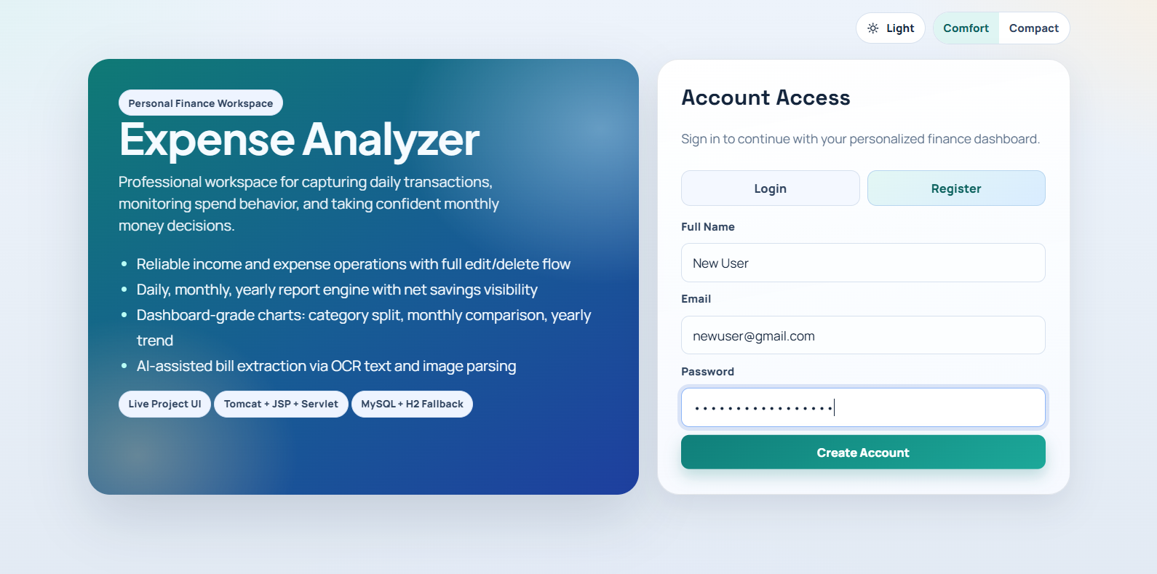

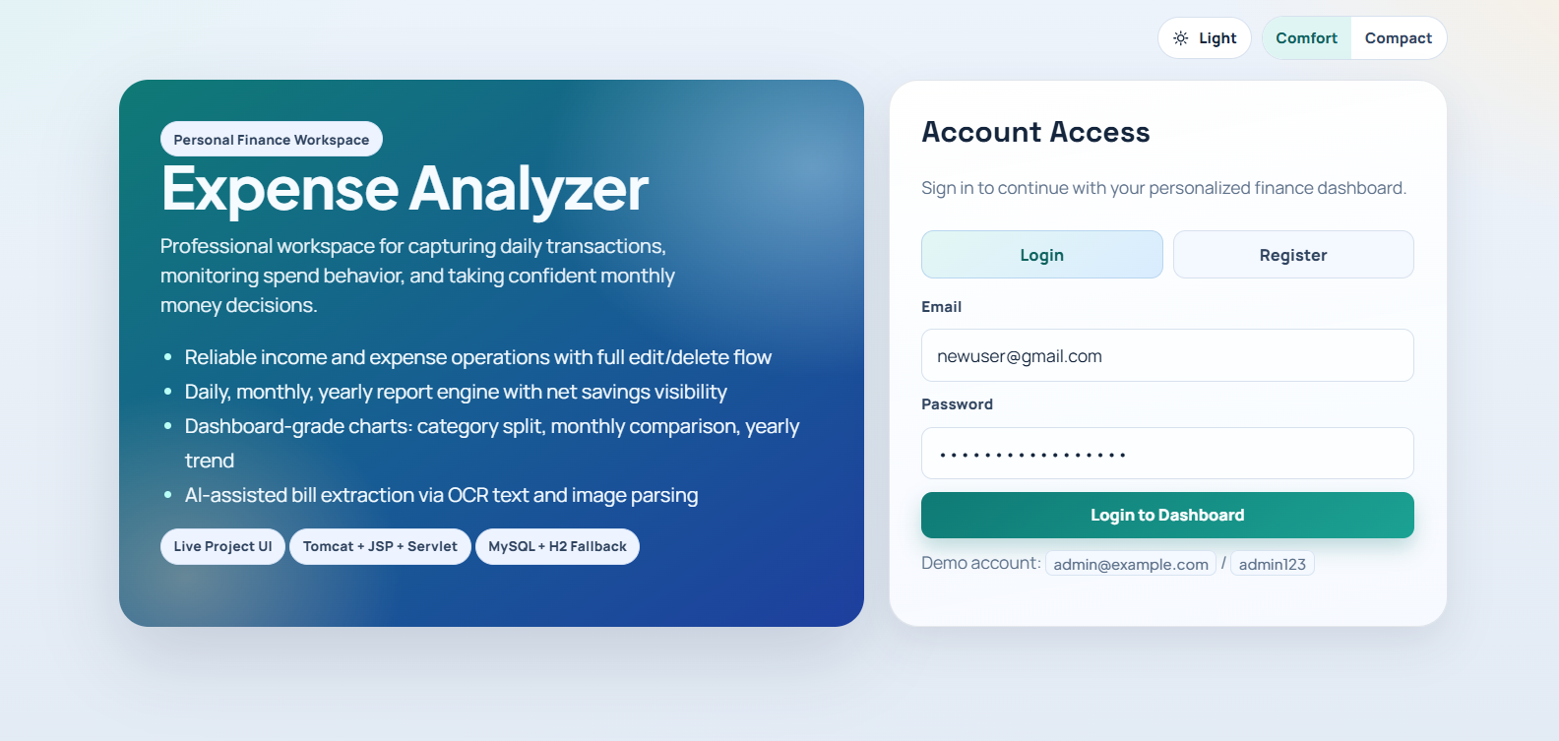

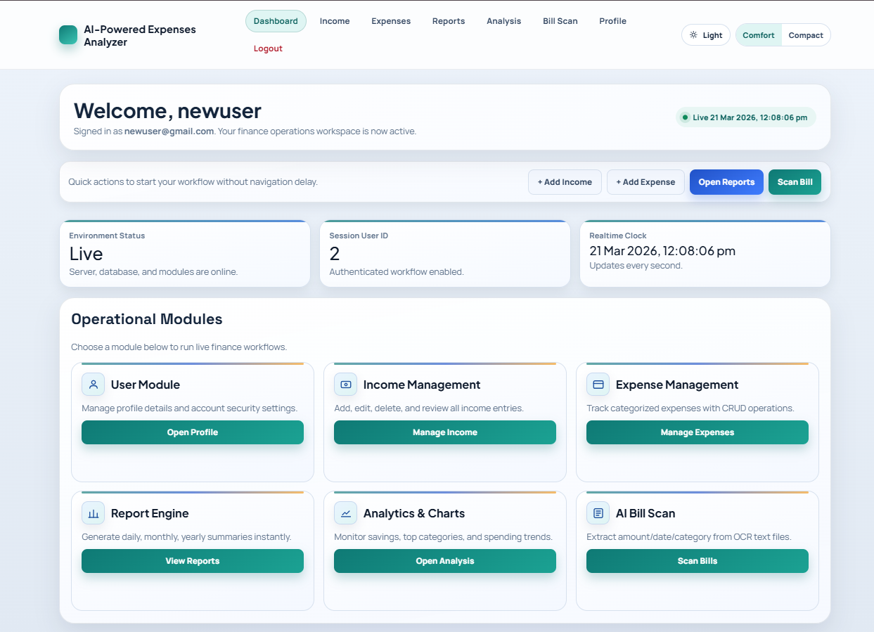

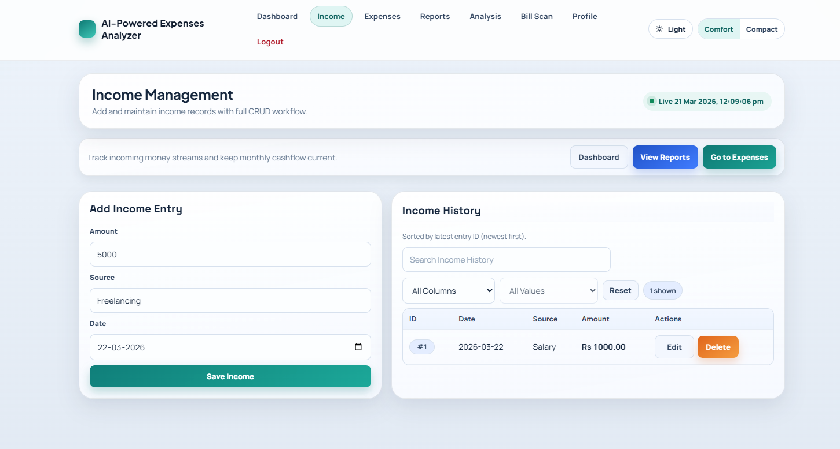

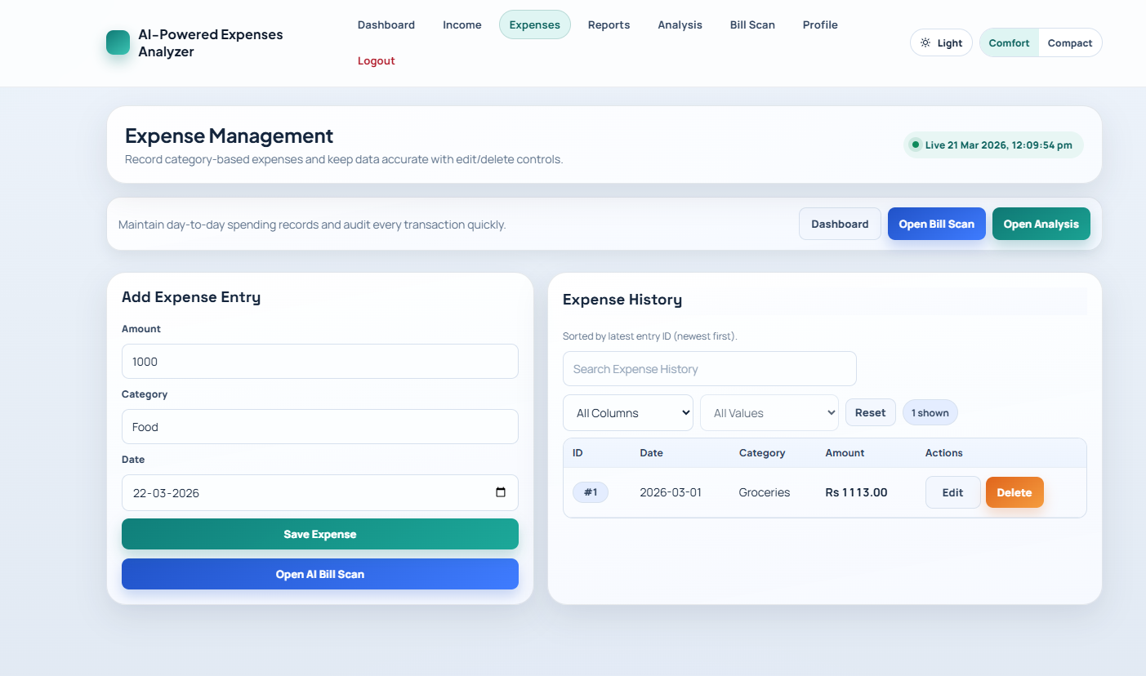

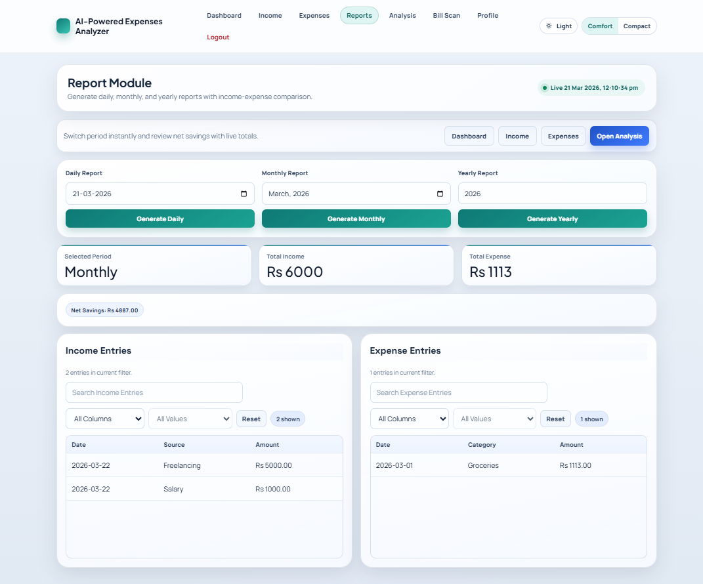

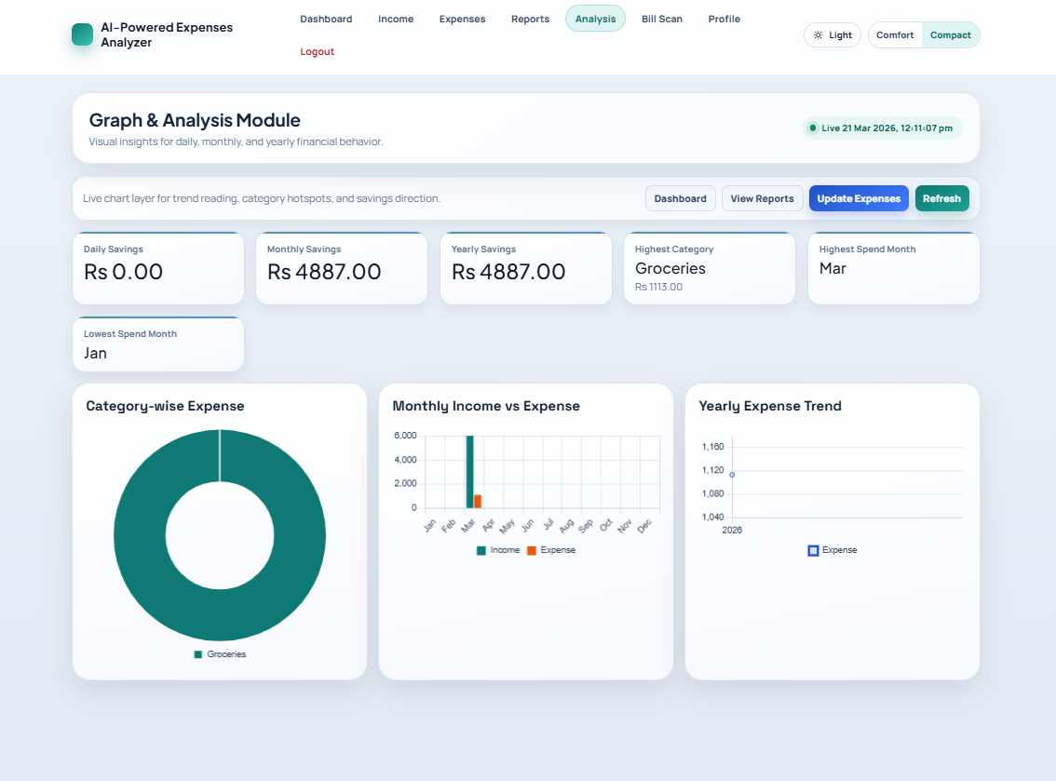

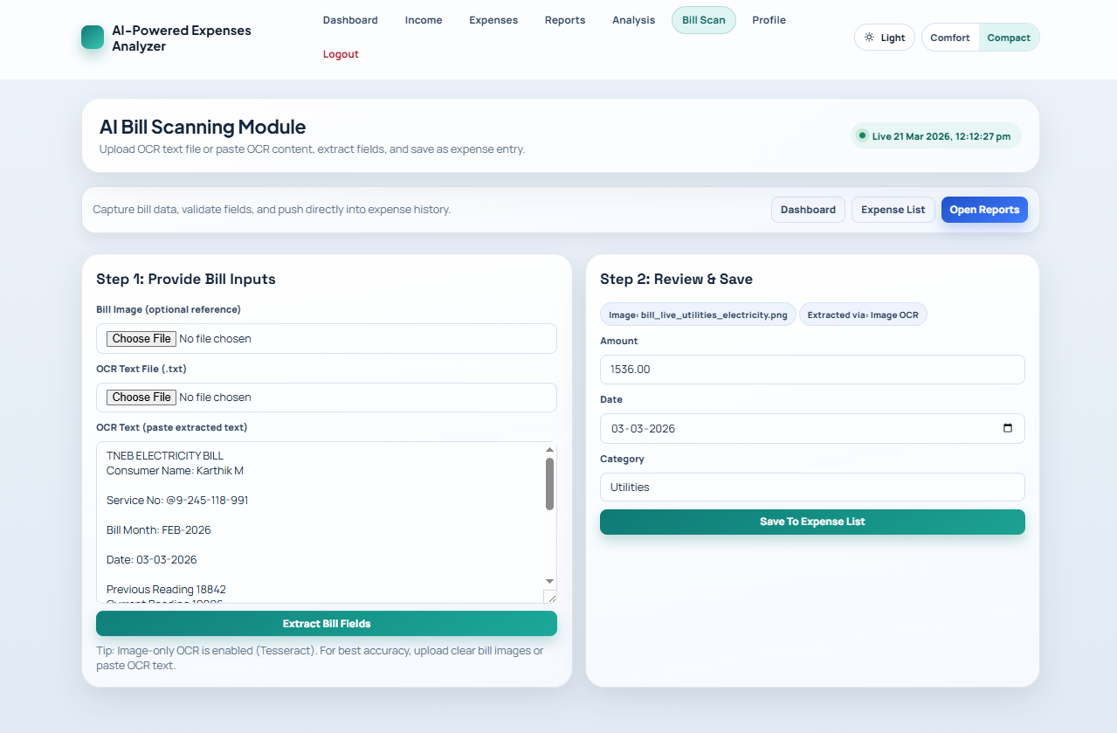

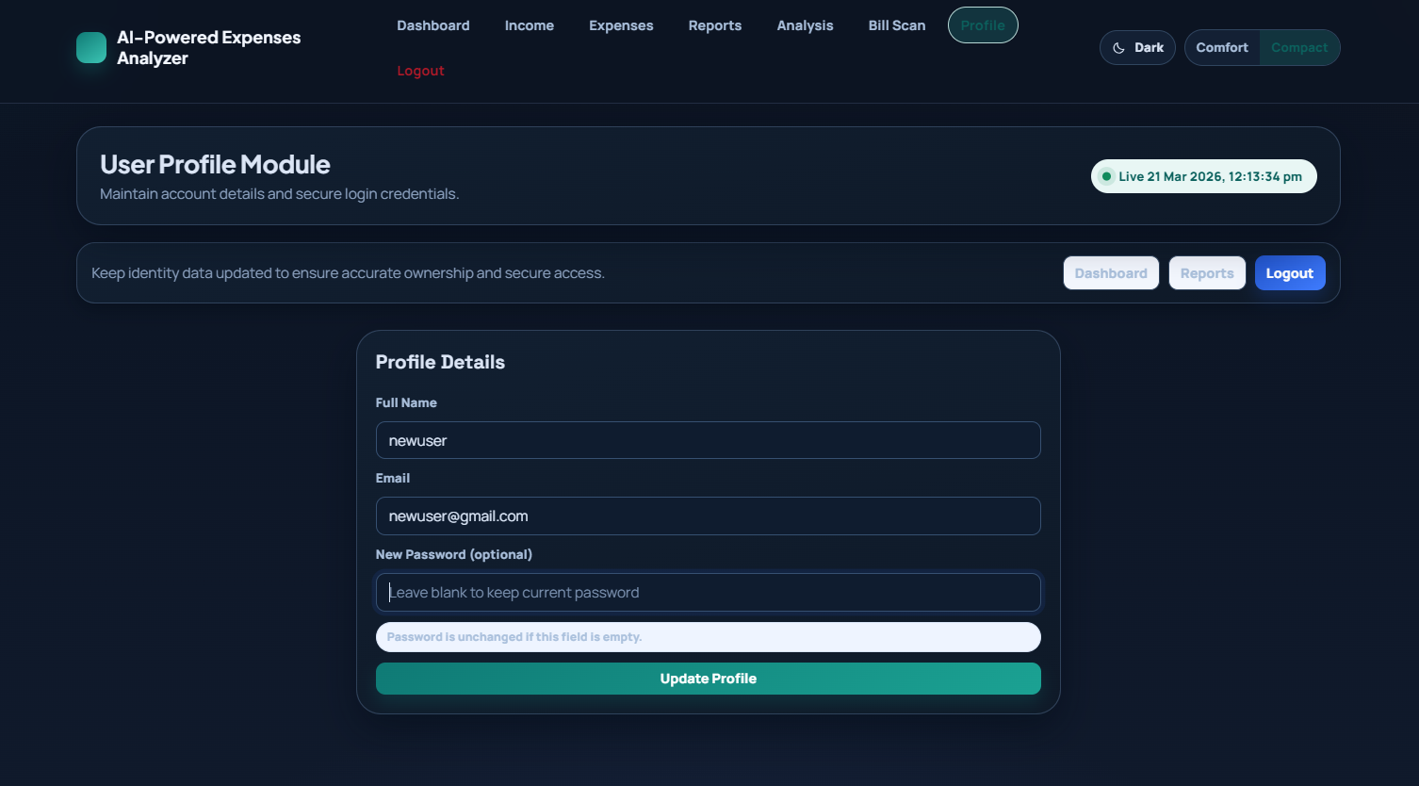

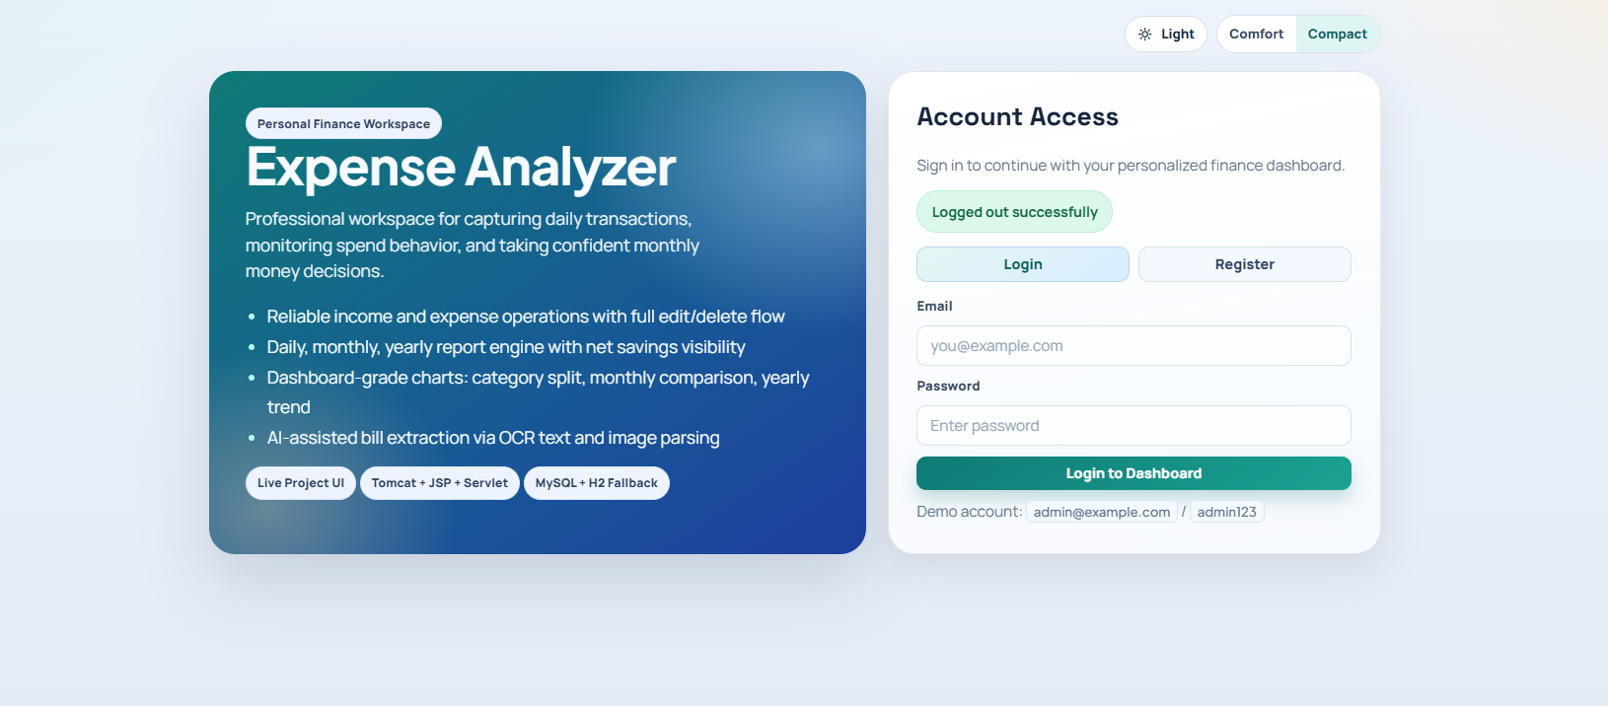

CHAPTER 6
TESTING

Testing Strategy
The testing strategy for the AI-Powered Expenses Analyzer is designed to ensure that the system functions correctly, efficiently, and reliably under different conditions. Testing is a crucial phase in the software development lifecycle, as it helps identify errors, improve performance, and validate that the system meets user requirements. A systematic approach is followed to test each module of the application thoroughly.
The testing process begins with unit testing, where individual components of the system are tested independently. Each module, such as user authentication, income management, expense tracking, and OCR processing, is tested to ensure that it performs its intended function correctly. For example, the login module is tested with valid and invalid credentials to verify authentication functionality. Similarly, the expense module is tested to ensure that data is correctly added, updated, and deleted.
After unit testing, integration testing is performed to verify that different modules of the system work together seamlessly. This involves testing the interaction between the frontend, backend, and database. For instance, when a user enters an expense in the frontend, the system should correctly process the request in the backend and store the data in the database. Integration testing ensures that data flows correctly between all components of the system.
System testing is conducted to evaluate the complete application as a whole. In this phase, the system is tested in an environment similar to real-world usage. All functionalities, including login, expense tracking, OCR scanning, report generation, and data visualization, are tested together. This ensures that the system behaves as expected under normal operating conditions.
Another important aspect of the testing strategy is functional testing. This involves verifying that all features of the system meet the specified requirements. Each function is tested with different input values to ensure correct output. For example, the report generation feature is tested to confirm that it accurately displays financial data based on user inputs.
Performance testing is carried out to evaluate the system’s responsiveness and stability. The system is tested with different amounts of data to ensure that it can handle moderate workloads without significant delays. The response time for operations such as data entry, report generation, and OCR processing is monitored to ensure acceptable performance levels.
Usability testing is also an important part of the strategy. The system is evaluated from the user’s perspective to ensure that it is easy to use and navigate. Feedback from users helps identify areas where the interface can be improved. A simple and intuitive design ensures that users can perform tasks without confusion.
Error handling and validation testing are performed to ensure that the system can handle invalid inputs and unexpected situations gracefully. Input validation checks are implemented to prevent incorrect data entry, and appropriate error messages are displayed to guide users.
Security testing is conducted to ensure that user data is protected. The authentication system is tested to prevent unauthorized access, and data handling processes are verified to maintain confidentiality.
Overall, the testing strategy ensures that the AI-Powered Expenses Analyzer is reliable, efficient, and user-friendly, meeting all functional and performance requirements.
Test Cases
Test Case ID | Module | Test Description | Input Data | Expected Result | Actual Result | Status
TC_01 | Authentication | User Registration | Valid name, email, password | User should be registered successfully | As Expected | Pass
TC_02 | Authentication | Login with valid credentials | Correct username & password | User should login successfully | As Expected | Pass
TC_03 | Authentication | Login with invalid credentials | Wrong username/password | Error message should be displayed | As Expected | Pass
TC_04 | Income Module | Add Income | Amount, date, source | Income should be added to database | As Expected | Pass
TC_05 | Income Module | Update Income | Modified income details | Income should be updated successfully | As Expected | Pass
TC_06 | Expense Module | Add Expense | Amount, category, date | Expense should be saved in database | As Expected | Pass
TC_07 | Expense Module | Delete Expense | Select expense record | Expense should be deleted | As Expected | Pass
TC_08 | OCR Module | Upload bill image | Valid bill image | Text should be extracted correctly | As Expected | Pass
TC_09 | OCR Module | Upload unclear image | Blurry image | Partial/incorrect extraction expected | As Expected | Pass
TC_10 | Reports Module | Generate monthly report | Select month | Report should display correct data | As Expected | Pass
TC_11 | Reports Module | View charts | Existing data | Graphs should be displayed properly | As Expected | Pass
TC_12 | Dashboard | Display summary | User data available | Dashboard should show totals correctly | As Expected | Pass
TC_13 | System | Logout | Click logout | User should be logged out | As Expected | Pass
TC_14 | Validation | Empty input fields | Blank form | Validation error should be shown | As Expected | Pass
TC_15 | Security | Unauthorized access | Direct URL access without login | Access should be denied | As Expected | Pass

Testing Results
The testing of the AI-Powered Expenses Analyzer was conducted systematically to evaluate the functionality, performance, reliability, and usability of the system. Various testing techniques such as unit testing, integration testing, system testing, and user acceptance testing were applied to ensure that all modules of the application work correctly and efficiently. The results obtained from these testing processes indicate that the system performs as expected under normal operating conditions.
During unit testing, individual modules such as user authentication, income management, expense tracking, OCR processing, and report generation were tested independently. Each module was verified with different input values to ensure correct functionality. The authentication module successfully validated user credentials and prevented unauthorized access. The income and expense modules accurately handled data entry, updates, and deletions, ensuring proper storage and retrieval from the database.
Integration testing was performed to ensure that different components of the system work together seamlessly. The interaction between the frontend, backend, and database was tested thoroughly. For example, when users entered expense data through the interface, the backend processed the request and stored the information in the database correctly. Similarly, data retrieved from the database was displayed accurately in the user interface. The integration of the OCR module with the expense system also worked effectively, allowing extracted data to be stored and processed without errors.
System testing evaluated the complete application in a real-world environment. All functionalities, including login, data entry, bill scanning, report generation, and logout, were tested together. The system demonstrated stable performance and handled user operations efficiently. The response time for most operations was satisfactory, and no major performance issues were observed.
The OCR functionality produced good results when tested with clear and properly captured images. The system was able to extract key details such as amount and date with reasonable accuracy. However, minor inaccuracies were observed when processing low-quality or blurred images. Despite this limitation, the OCR module significantly reduced manual effort and improved overall efficiency.
Usability testing indicated that the system is user-friendly and easy to navigate. Users were able to perform tasks such as adding expenses, viewing reports, and scanning bills without difficulty. The interface design was simple and intuitive, contributing to a positive user experience.
Validation and error handling mechanisms were also tested. The system successfully prevented invalid data entry and displayed appropriate error messages when required. Security testing confirmed that user data is protected through authentication and session management, preventing unauthorized access.
Overall, the testing results confirm that the AI-Powered Expenses Analyzer is a reliable and efficient system. It meets the functional requirements and performs well under typical usage conditions, providing users with a practical solution for managing personal finances.

CHAPTER 7
CONCLUSION

The AI-Powered Expenses Analyzer is a comprehensive and efficient solution designed to simplify personal financial management through automation and intelligent data processing. The project successfully integrates web technologies with basic artificial intelligence concepts to provide a user-friendly platform for tracking income and expenses. It addresses the limitations of traditional expense management methods by reducing manual effort, improving accuracy, and providing meaningful insights into financial activities.
The system allows users to record, update, and manage their financial data in a structured manner. With features such as income and expense tracking, report generation, and graphical data visualization, users can easily monitor their financial status and identify spending patterns. The use of charts and reports enhances the understanding of financial data, enabling users to make informed decisions and improve their budgeting habits.
One of the key highlights of the project is the integration of Optical Character Recognition (OCR) technology. This feature enables automatic extraction of data from bills and receipts, significantly reducing the need for manual data entry. The OCR module demonstrates the practical application of AI-based techniques in real-world scenarios, making the system more advanced and efficient compared to conventional expense tracking applications.
The project is developed using Java Servlets, JSP, and MySQL, ensuring a reliable and scalable system architecture. The use of Apache Tomcat as the deployment server provides a stable environment for running the application. The modular design of the system allows easy maintenance and future enhancements, making it adaptable to evolving user needs.
Throughout the development process, various testing techniques were applied to ensure the quality and performance of the system. The results indicate that the application functions correctly and meets all specified requirements. The system performs efficiently under normal conditions and provides accurate outputs for different operations.
The AI-Powered Expenses Analyzer not only improves financial tracking but also promotes better financial awareness among users. By providing a centralized platform with automation and analysis features, the system helps users manage their finances more effectively and avoid unnecessary expenses.
Overall, the project demonstrates the successful implementation of a smart expense management system that combines traditional functionality with modern technology. It serves as a valuable tool for individuals seeking better control over their financial activities and showcases the potential of integrating web development with intelligent automation techniques.

CHAPTER 8
FUTURE WORK

The AI-Powered Expenses Analyzer provides a strong foundation for personal financial management; however, there are several opportunities to enhance its functionality and expand its capabilities in the future. With continuous advancements in technology, the system can be further improved to offer more intelligent, scalable, and user-centric features.
One of the major areas for future enhancement is the integration of advanced artificial intelligence and machine learning techniques. Currently, the system uses OCR for extracting data from bills, but it can be extended to include intelligent expense categorization and prediction. Machine learning models can analyze past spending patterns and provide personalized recommendations, helping users make better financial decisions. Predictive analytics can also be implemented to forecast future expenses and savings.
Another important improvement is the development of a mobile application. A dedicated mobile app for Android and iOS platforms would make the system more accessible and convenient for users. Mobile integration would allow users to track expenses on the go, capture bill images instantly, and receive real-time notifications about their financial activities.
The system can also be enhanced by integrating with banking and payment systems. By connecting with bank APIs, the application can automatically fetch transaction details, eliminating the need for manual data entry. This would make the system more accurate and efficient while providing real-time updates of financial data.
Cloud integration is another potential area for improvement. Storing data on cloud platforms would ensure better scalability, security, and accessibility. Users would be able to access their financial data from anywhere, and the system could handle a larger number of users without performance issues. Cloud-based backup and recovery mechanisms would further enhance data safety.
The OCR module can be improved to support multiple languages and handle a wider variety of bill formats. Enhancing image processing techniques can increase accuracy, even for low-quality or handwritten receipts. Integration with advanced OCR tools or AI-based vision systems can further improve performance.
Another future enhancement is the addition of budgeting and goal-setting features. Users can set monthly budgets or financial goals, and the system can track their progress. Notifications and alerts can be implemented to warn users when they exceed their budget or approach spending limits.
Security can also be strengthened by implementing advanced authentication mechanisms such as two-factor authentication (2FA) or biometric verification. This would provide an additional layer of protection for sensitive financial data.
The system can also include multi-user support, allowing families or groups to manage shared expenses. Features such as expense splitting and collaborative budgeting can make the application more versatile.
Overall, the future enhancements aim to transform the AI-Powered Expenses Analyzer into a more intelligent, scalable, and feature-rich financial management system that meets the evolving needs of users.

REFERENCES
[1] A. F. Saad, M. H. Shaharudin, A. Yani, and A. Manaf, “Development of a Student Expense Tracking System Using Optical Character Recognition,” International Journal of Artificial Intelligence, vol. 12, no. 1, pp. 1–16, 2025.
[2] P. J, S. Puneeth, U. S. Tiwari, V. D. N, and A. U. A, “OCR in Finance: A Web-Based Approach for Personalized Expense Tracking and Budget Monitoring,” International Journal of Advanced Research in Science, Communication and Technology, vol. 5, no. 4, pp. 290–295, 2025.
[3] B. D. Reddy et al., “Expense Tracker – An Expense Tracking Application Using OCR and Random Forest Algorithm,” ResearchGate Publication, 2025.
[4] S. Kumar et al., “Design and Implementation of a Modern Expense Tracker Application,” International Journal of Scientific Research & Engineering Trends, vol. 11, no. 6, 2025.
[5] R. Sharma et al., “Implementation of an Expense Tracker using Python,” International Journal of Future Machine Learning Research, 2025.
[6] A. Rexhepi, “Invoice and Receipt Optical Character Recognition: Review on Open Source Approaches,” CEUR Workshop Proceedings, 2025.
[7] J. Patel, “Design and Implementation of an OCR-Powered Pipeline for Invoice Data Extraction,” arXiv preprint arXiv:2507.07029, 2025.
[8] C. Jeong et al., “E2E Process Automation Leveraging Generative AI and Intelligent Document Processing,” arXiv preprint arXiv:2505.20733, 2025.
[9] S. Luo et al., “Deep Structured Feature Networks for Table Detection and Data Extraction from Financial Documents,” IEEE Access, 2021.
[10] M. Singh et al., “Automated Expense Tracking with OCR: Enhancing Financial Management through Technology,” IARJSET, 2024.

APPENDIX A
SOURCE CODE

1. Frontend Sample - `login.jsp`

<%@ page language="java" contentType="text/html; charset=UTF-8" pageEncoding="UTF-8"%>
<%
Integer userId = (Integer) session.getAttribute("userId");
if (userId != null) {
response.sendRedirect("dashboard.jsp");
return;
}
String msg = request.getParameter("msg");
String error = request.getParameter("error");
%>
<!DOCTYPE html>
<html>
<head>
<title>AI-Powered Expenses Analyzer</title>
<meta name="viewport" content="width=device-width, initial-scale=1.0">
<link rel="stylesheet" href="assets/css/app.css">
</head>
<body class="app-body">
<div class="auth-shell">
<section class="auth-card">
<h2>Account Access</h2>

<% if (msg != null) { %>
<div class="flash ok"><%= msg %></div>
<% } %>
<% if (error != null) { %>
<div class="flash err"><%= error %></div>
<% } %>

<form action="AuthServlet" method="post">
<input type="hidden" name="action" value="login">
<label>Email</label>
<input type="email" name="email" required>
<label>Password</label>
<input type="password" name="password" required>
<button type="submit">Login to Dashboard</button>
</form>
</section>
</div>
<script src="assets/js/app.js"></script>
</body>
</html>

- Backend Controller Sample - `AuthServlet.java`

package com.expenses.controller;

import com.expenses.dao.UserDAO;
import com.expenses.model.User;
import java.io.IOException;
import javax.servlet.ServletException;
import javax.servlet.http.HttpServlet;
import javax.servlet.http.HttpServletRequest;
import javax.servlet.http.HttpServletResponse;
import javax.servlet.http.HttpSession;

public class AuthServlet extends HttpServlet {
private static final long serialVersionUID = 1L;
private final UserDAO userDAO = new UserDAO();

@Override
protected void doPost(HttpServletRequest request, HttpServletResponse response)
throws ServletException, IOException {
String action = request.getParameter("action");

if ("register".equalsIgnoreCase(action)) {
String name = request.getParameter("name");
String email = request.getParameter("email");
String password = request.getParameter("password");

boolean created = userDAO.registerUser(new User(name, email, password));
if (!created) {
response.sendRedirect("login.jsp?error=Registration failed");
return;
}
}

String email = request.getParameter("email");
String password = request.getParameter("password");
User user = userDAO.authenticate(email, password);

if (user == null) {
response.sendRedirect("login.jsp?error=Invalid email or password");
return;
}

HttpSession session = request.getSession(true);
session.setAttribute("userId", user.getId());
session.setAttribute("userName", user.getName());
session.setAttribute("userEmail", user.getEmail());

response.sendRedirect("dashboard.jsp");
}
}

3. DAO Layer Sample - `ExpenseDAO.java`

package com.expenses.dao;

import com.expenses.model.Expense;
import java.sql.Connection;
import java.sql.PreparedStatement;
import java.sql.ResultSet;
import java.sql.SQLException;
import java.util.ArrayList;
import java.util.List;

public class ExpenseDAO {

public boolean addExpense(int userId, double amount, String category, String date) {
String sql = "INSERT INTO expense(user_id,amount,category,date) VALUES(?,?,?,?)";
try (Connection con = DBConnection.getConnection();
PreparedStatement ps = con.prepareStatement(sql)) {
ps.setInt(1, userId);
ps.setDouble(2, amount);
ps.setString(3, category);
ps.setString(4, date);
return ps.executeUpdate() > 0;
} catch (SQLException e) {
e.printStackTrace();
return false;
}
}

public List<Expense> getAllExpenses(int userId) {
String sql = "SELECT id, user_id, amount, category, date FROM expense WHERE user_id=? ORDER BY id DESC";
List<Expense> list = new ArrayList<>();

try (Connection con = DBConnection.getConnection();
PreparedStatement ps = con.prepareStatement(sql)) {
ps.setInt(1, userId);
try (ResultSet rs = ps.executeQuery()) {
while (rs.next()) {
list.add(new Expense(
rs.getInt("id"),
rs.getInt("user_id"),
rs.getDouble("amount"),
rs.getString("category"),
rs.getString("date")
));
}
}
} catch (SQLException e) {
e.printStackTrace();
}
return list;
}
}

4. Model Class Sample - `Expense.java`

package com.expenses.model;

public class Expense {
private int id;
private int userId;
private double amount;
private String category;
private String date;

public Expense(int userId, double amount, String category, String date) {
this.userId = userId;
this.amount = amount;
this.category = category;
this.date = date;
}

public Expense(int id, int userId, double amount, String category, String date) {
this.id = id;
this.userId = userId;
this.amount = amount;
this.category = category;
this.date = date;
}

public int getId() {
return id;
}

public int getUserId() {
return userId;
}

public double getAmount() {
return amount;
}

public String getCategory() {
return category;
}

public String getDate() {
return date;
}
}

5. Database Sample - `schema.sql`

CREATE DATABASE IF NOT EXISTS expense_db;
USE expense_db;

CREATE TABLE IF NOT EXISTS users (
id INT AUTO_INCREMENT PRIMARY KEY,
name VARCHAR(100) NOT NULL,
email VARCHAR(100) NOT NULL UNIQUE,
password VARCHAR(255) NOT NULL
);

CREATE TABLE IF NOT EXISTS income (
id INT AUTO_INCREMENT PRIMARY KEY,
user_id INT NOT NULL,
amount DOUBLE NOT NULL,
source VARCHAR(255) NOT NULL,
date DATE NOT NULL,
FOREIGN KEY (user_id) REFERENCES users(id) ON DELETE CASCADE
);

CREATE TABLE IF NOT EXISTS expense (
id INT AUTO_INCREMENT PRIMARY KEY,
user_id INT NOT NULL,
amount DOUBLE NOT NULL,
category VARCHAR(255) NOT NULL,
date DATE NOT NULL,
FOREIGN KEY (user_id) REFERENCES users(id) ON DELETE CASCADE
);

INSERT INTO users (id, name, email, password)
SELECT 1, 'Admin', 'admin@example.com', 'admin123'
WHERE NOT EXISTS (SELECT 1 FROM users WHERE id = 1);

6. Configuration Sample - `web.xml`
<?xml version="1.0" encoding="UTF-8"?>
<web-app xmlns="http://xmlns.jcp.org/xml/ns/javaee"
xmlns:xsi="http://www.w3.org/2001/XMLSchema-instance"
xsi:schemaLocation="http://xmlns.jcp.org/xml/ns/javaee
http://xmlns.jcp.org/xml/ns/javaee/web-app_4_0.xsd"
version="4.0">

<display-name>ExpenseAnalyzer</display-name>

<servlet>
<servlet-name>AuthServlet</servlet-name>
<servlet-class>com.expenses.controller.AuthServlet</servlet-class>
</servlet>
<servlet-mapping>
<servlet-name>AuthServlet</servlet-name>
<url-pattern>/AuthServlet</url-pattern>
</servlet-mapping>

<servlet>
<servlet-name>ExpenseServlet</servlet-name>
<servlet-class>com.expenses.controller.ExpenseServlet</servlet-class>
</servlet>
<servlet-mapping>
<servlet-name>ExpenseServlet</servlet-name>
<url-pattern>/ExpenseServlet</url-pattern>
</servlet-mapping>

<welcome-file-list>
<welcome-file>login.jsp</welcome-file>
</welcome-file-list>

</web-app>
```

7. Optional AI Module Sample - `BillScanServlet.java`

private double extractAmount(String text) {
if (text == null || text.trim().isEmpty()) {
return 0.0;
}

String normalizedText = text.replace(",", "");
java.util.regex.Pattern pattern = java.util.regex.Pattern.compile("(\\d+(?:\\.\\d{1,2})?)");
java.util.regex.Matcher matcher = pattern.matcher(normalizedText);

double maxAmount = 0.0;
while (matcher.find()) {
double value = Double.parseDouble(matcher.group(1));
if (value > maxAmount) {
maxAmount = value;
}
}
return maxAmount;
}

private String guessCategory(String text) {
String lower = text.toLowerCase();

if (lower.contains("fuel") || lower.contains("petrol") || lower.contains("diesel")) {
return "Travel";
} else if (lower.contains("restaurant") || lower.contains("food")) {
return "Food";
} else if (lower.contains("grocery") || lower.contains("market")) {
return "Groceries";
} else if (lower.contains("electricity") || lower.contains("water")) {
return "Utilities";
}
return "Misc";
}

